Pads and Phalanges
Draw lines to connect the word to the part on the paw.
Phalangeal Pad
Carpal Pad
Dew Claw
Metacarpal Pad
Inner Phalangeal Pad
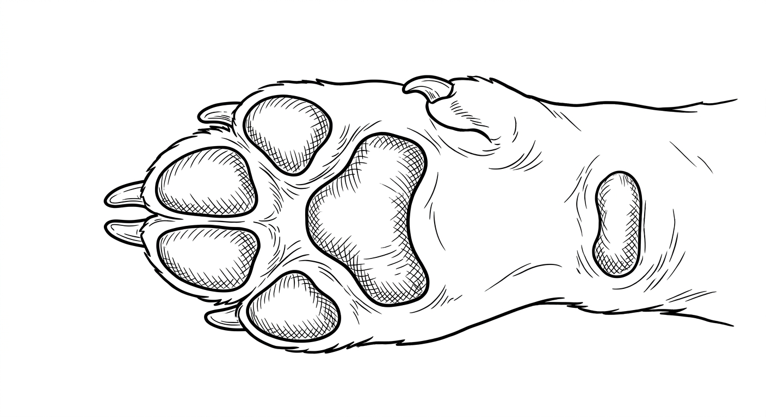
Outer Phalangeal Pad
1st Toe
3th Toe, digit, or phalange
Stopper pad or carpal cushion
2th Toe, digit, or phalange
5th Toe, digit, or phalange
4th Toe, digit, or phalange
Colorado State University Extension is an equal opportunity provider. Colorado State University Extension es un proveedor que ofrece igualdad de oportunidades. https://col.st/0WMJA

