Pad and Phalanges
Label the pads and then match the definitions.

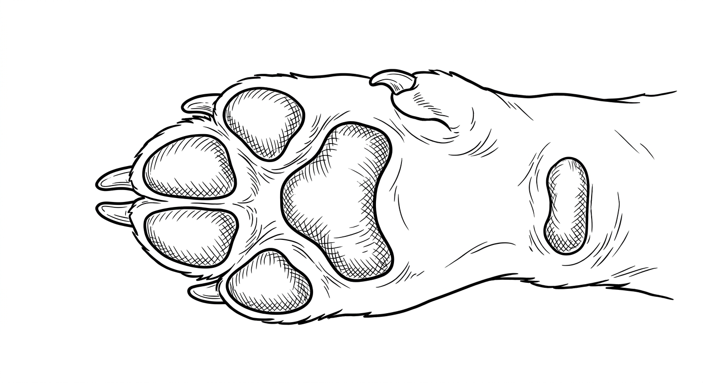

Phalangeal Pad 1st Toe
Carpal Pad 5th Toe, digit, or phalange
Dew Claw 3th Toe, digit, or phalange
Metacarpal Pad 2th Toe, digit, or phalange
Inner Phalangeal Pad 4th Toe, digit, or phalange
Outer Phalangeal Pad Stopper pad or carpal cushion

Colorado State University Extension is an equal opportunity provider. Colorado State University Extension es un proveedor que ofrece igualdad de oportunidades. https://col.st/0WMJA

