Bones of the Front Leg
Identify each bone or joint.

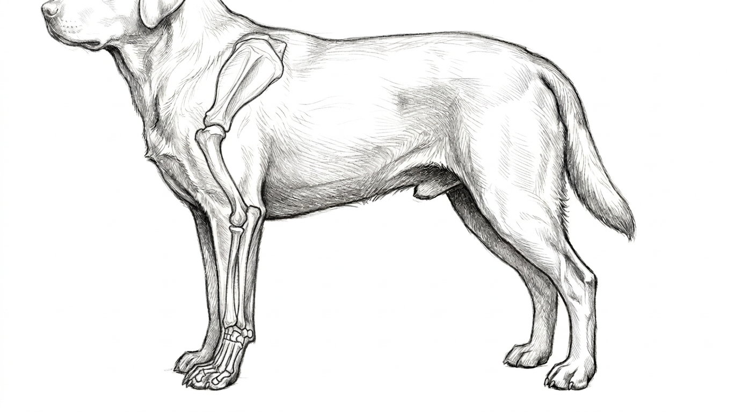

Colorado State University Extension is an equal opportunity provider. Colorado State University Extension es un proveedor que ofrece igualdad de oportunidades. https://col.st/0WMJA

