Bones of the Front Leg
Use a letter to identify each bone.

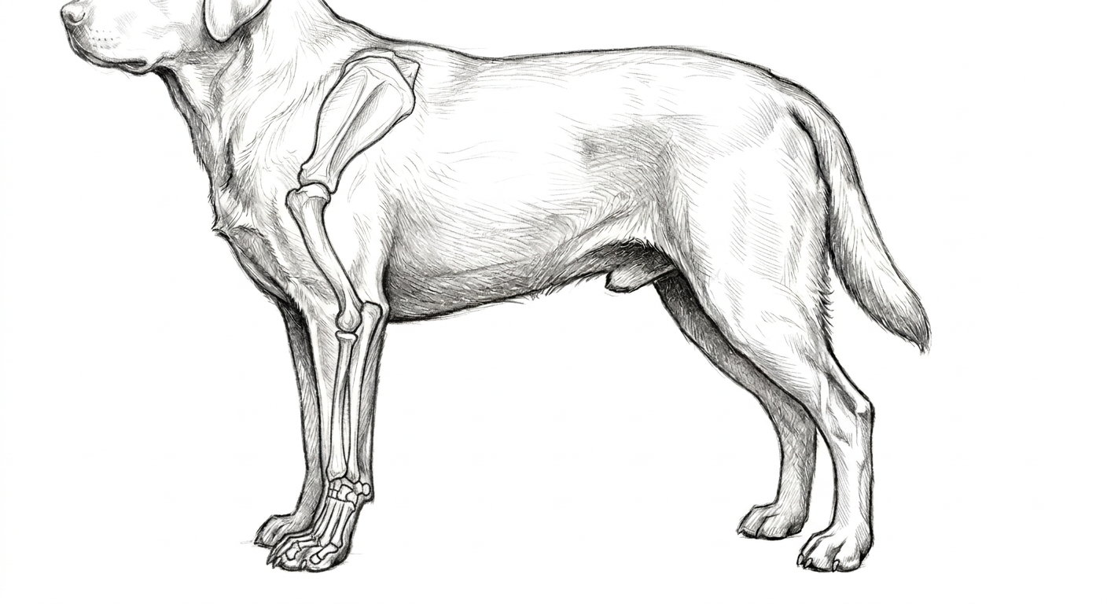
- Carpus
- Ulna
- Metacaupus
- Humerus
- Scapula
- Elbow joint
- Shoulder joint
- Radius

Colorado State University Extension is an equal opportunity provider. Colorado State University Extension es un proveedor que ofrece igualdad de oportunidades. https://col.st/0WMJA

