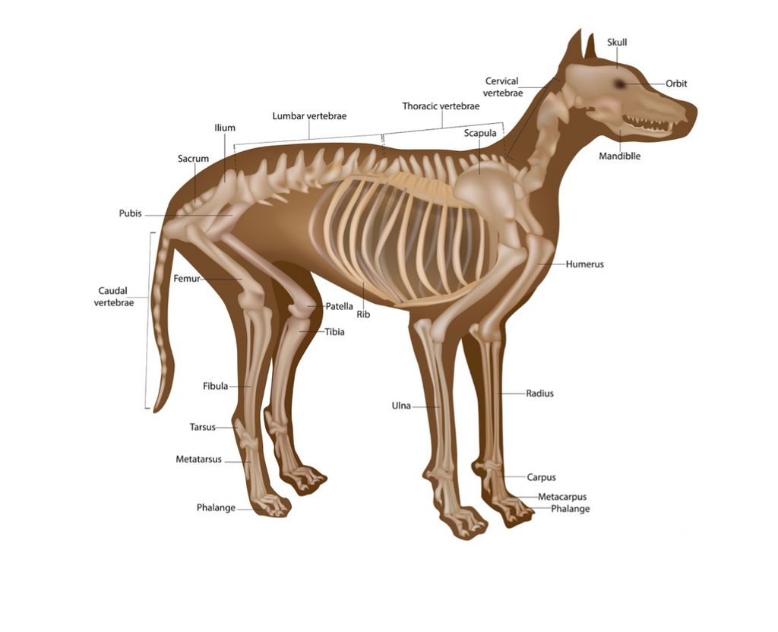

Adobe Stock Image
Colorado State University Extension is an equal opportunity provider. Colorado State University Extension es un proveedor que ofrece igualdad de oportunidades. https://col.st/0WMJA

