Whole Body Canine Bone Structure
Name as many bones as you can.
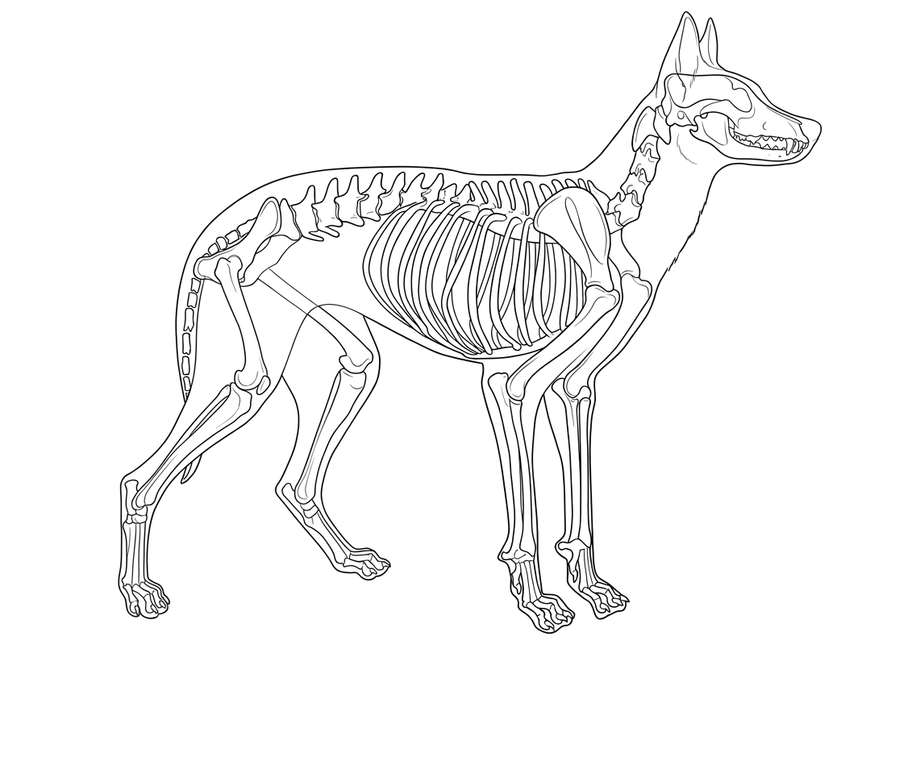
Colorado State University Extension is an equal opportunity provider. Colorado State University Extension es un proveedor que ofrece igualdad de oportunidades. https://col.st/0WMJA

