Whole Body Canine Bone Structure
Indicate the following bones by labeling the picture:
os coxae, tibia, femur, metatarsus, ulna, sternum, fibula, phalanges, humerus, mandible, orbit, kneecap, hock, pelvis
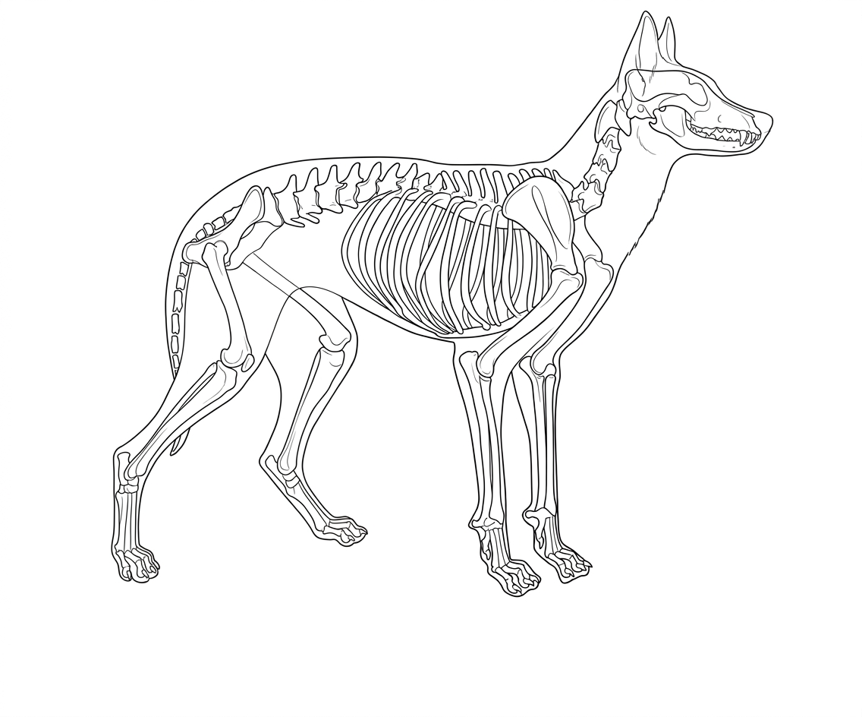Colorado State University Extension is an equal opportunity provider. Colorado State University Extension es un proveedor queofrece igualdad de oportunidades. https://col.st/0WMJA

