Whole Body Canine Bone Structure
Indicate the following bones by labeling the picture:
skull, maxilla, scapula, all 5 sections of vertebrae, femur, elbow joint, tarsus, carpus, ulna, sternum, patella, ribs, scapula, occiput, radius
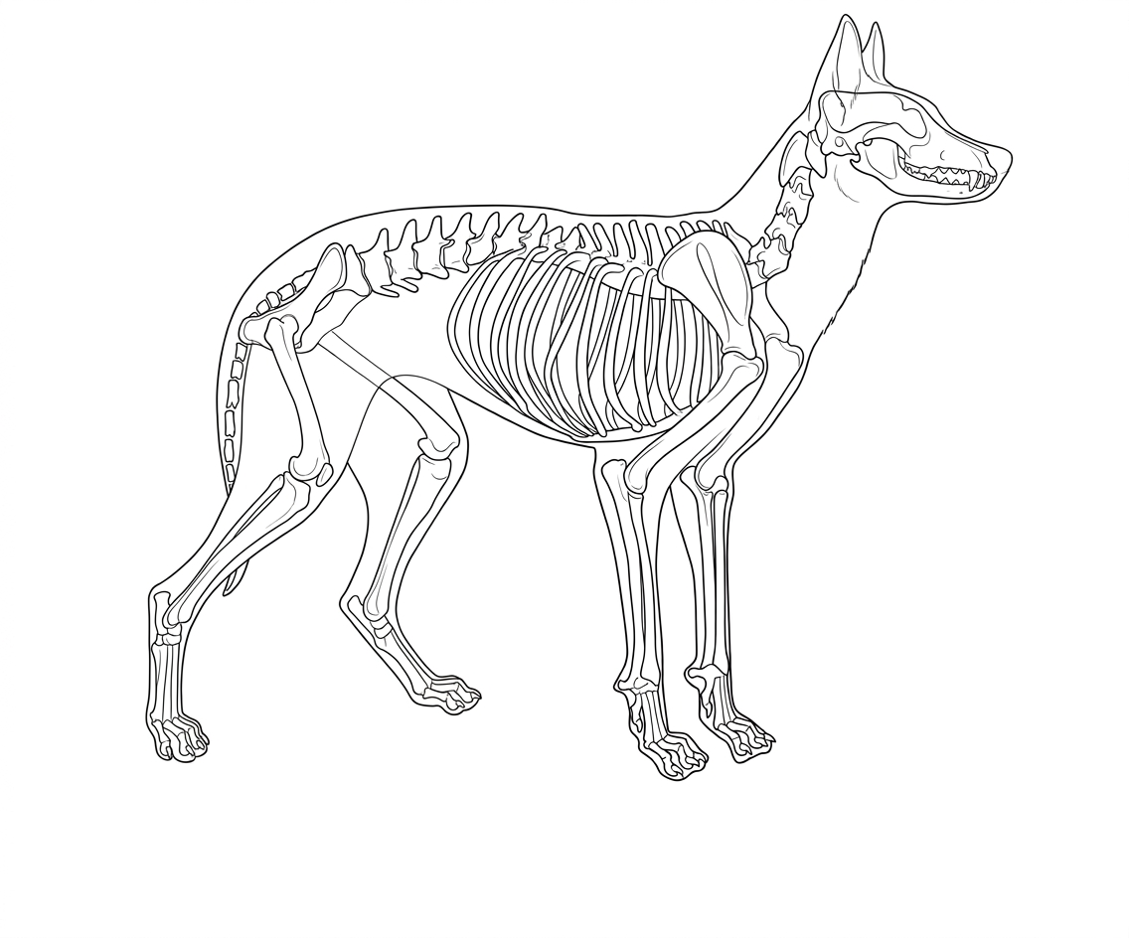Colorado State University Extension is an equal opportunity provider. Colorado State University Extension es un proveedor que ofrece igualdad de oportunidades . https://col.st/0WMJA

