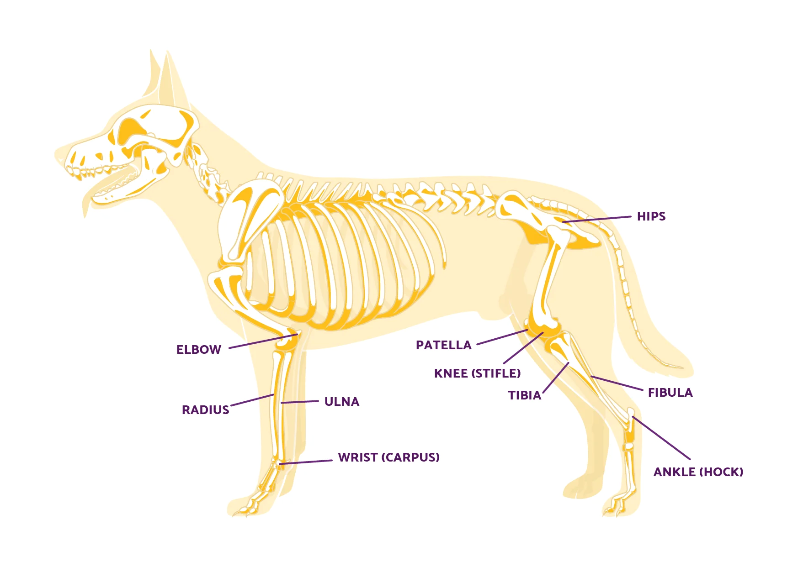

Image source: https://orthodog.com/blogs/sit-stay-heal/dog-leg-anatomy-in-human-terms?srsltid=AfmBOoq5TRcX4mjFCkQPFqp-wLE-lK2jXdwc3xBHGC7u9Jeld1lovyi2
Colorado State University Extension is an equal opportunity provider. Colorado State University Extension es un proveedor que ofrece igualdad de oportunidades. https://col.st/0WMJA

