Hindquarters
Label each area.
Some bones may have more than one term.

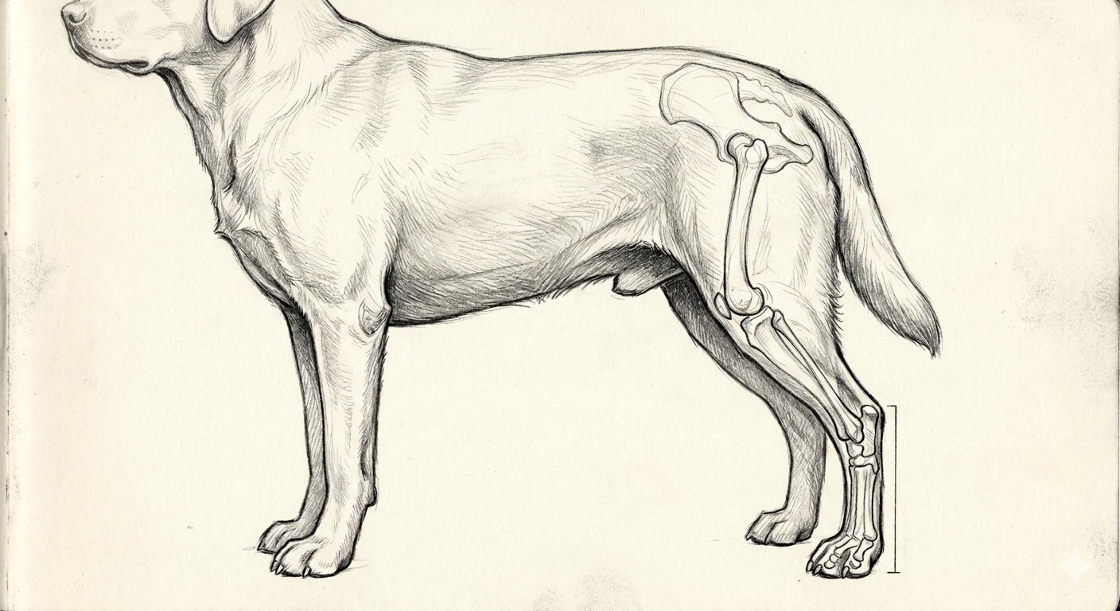

Colorado State University Extension is an equal opportunity provider. Colorado State University Extension es un proveedor que ofrece igualdad de oportunidades. https://col.st/0WMJA

