Hindquarters
Write the correct number next to the bone.
Some bones may have more than one term.

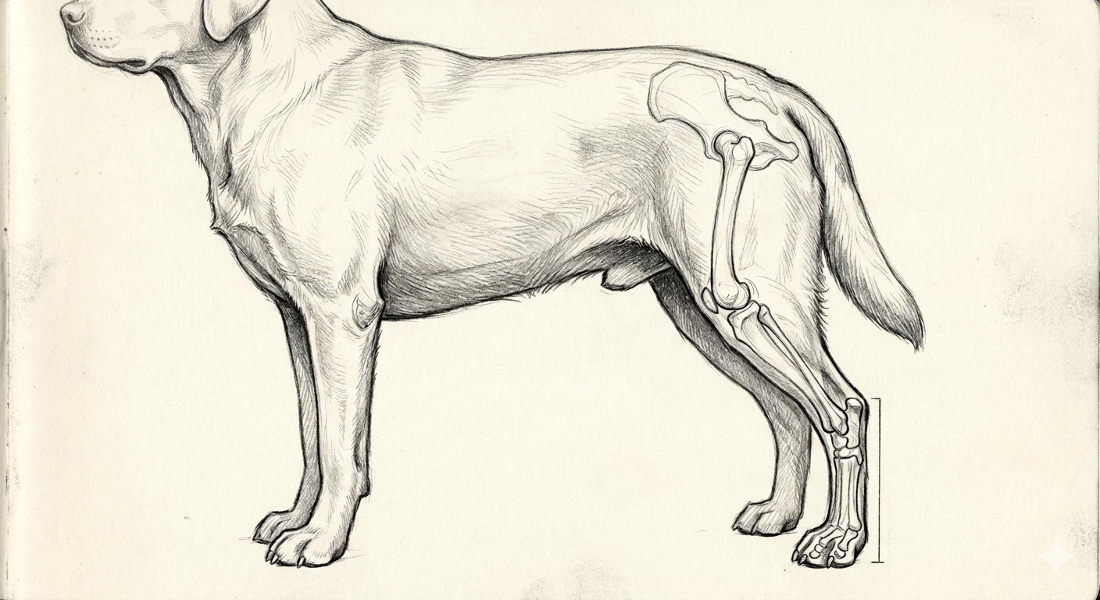

- pastern
- tarsus or
- phalanges
- stifle
- hock
- os coxae
- fibula
- metatarsus
- patella
- tarsus
- pelvis
- tibia
- hip
- hock
Colorado State University Extension is an equal opportunity provider. Colorado State University Extension es un proveedor que ofrece igualdad de oportunidades. https://col.st/0WMJA

