Hindquarters
Match the letter to the name of the bone.
C

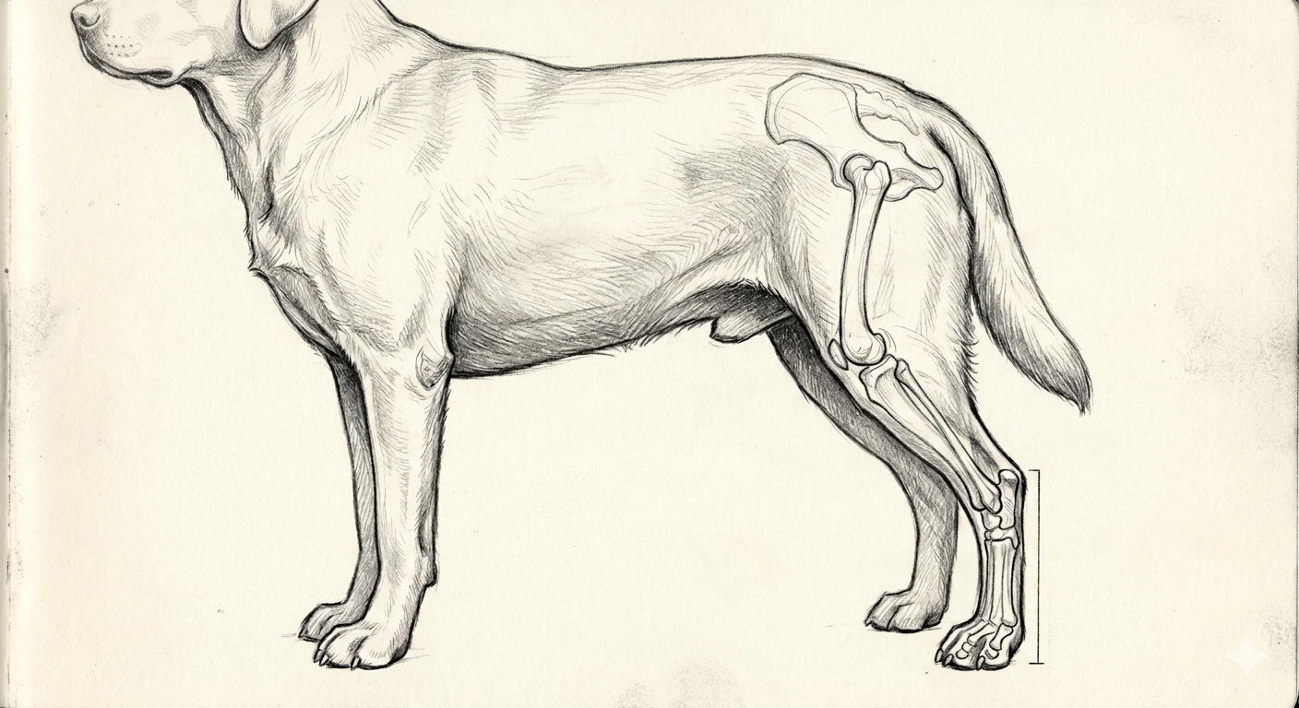
I
A
G
H
E
D
F
B

_______ phalanges _______ tarsus or hock
_______ stifle _______ tibia
_______ fibula _______ hip
_______ metatarsus or pastern _______ os coxae or pelvis
_______ patella

Colorado State University Extension is an equal opportunity provider. Colorado State University Extension es un proveedor que ofrece igualdad de oportunidades. https://col.st/0WMJA

