Head and Neck Bones
Write the name of the bone on the line.

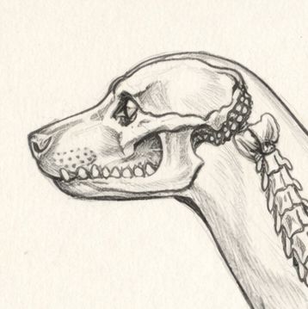

Colorado State University Extension is an equal opportunity provider. Colorado State University Extension es un proveedor que ofrece igualdad de oportunidades. https://col.st/0WMJA

