Body & Topline Labeling
Draw and then label all anatomical structures in the body and topline.

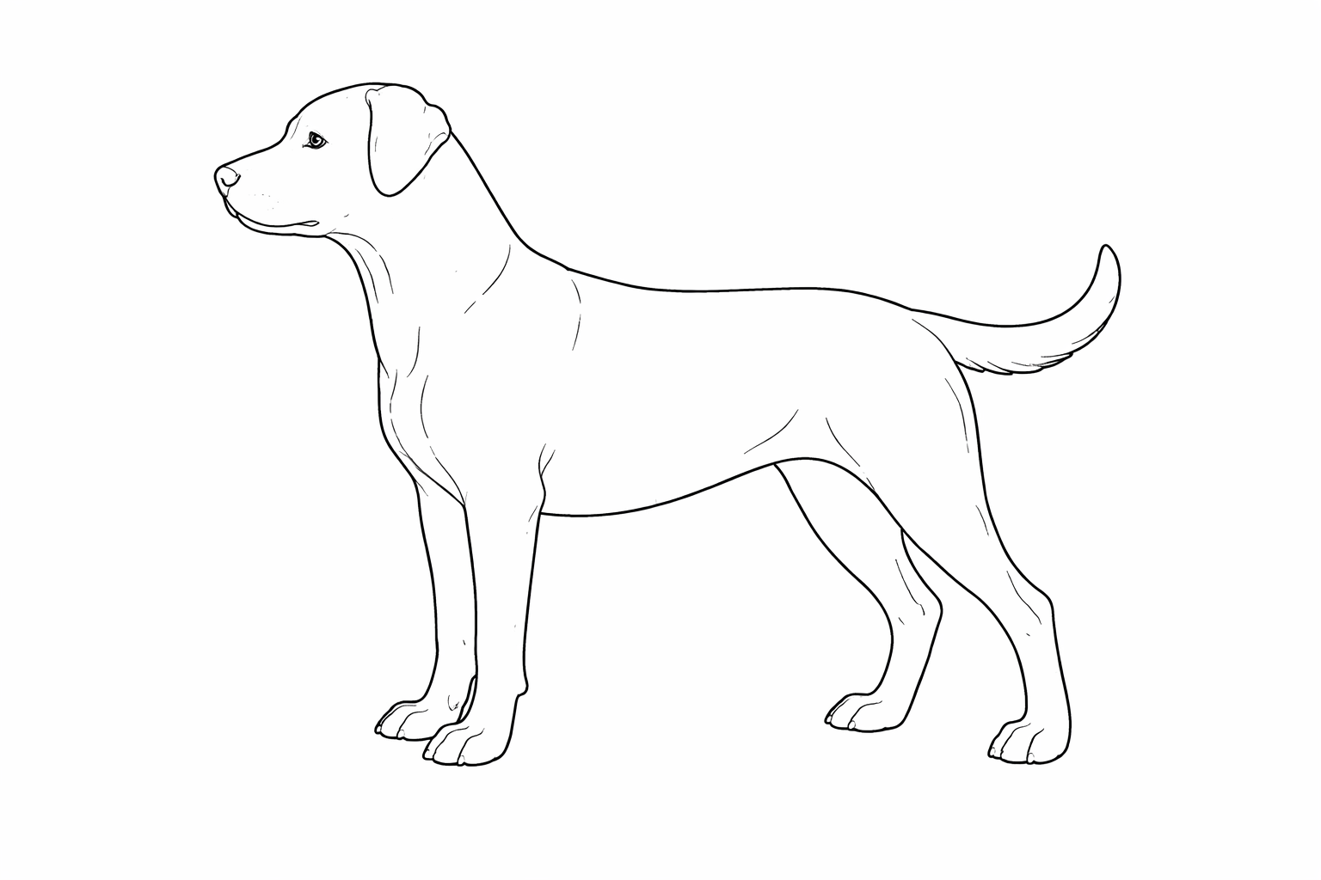

Colorado State University Extension is an equal opportunity provider. Colorado State University Extension es un proveedor que ofrece igualdad de oportunidades. https://col.st/0WMJA

