Body and Topline Labeling
Label all anatomical structures.
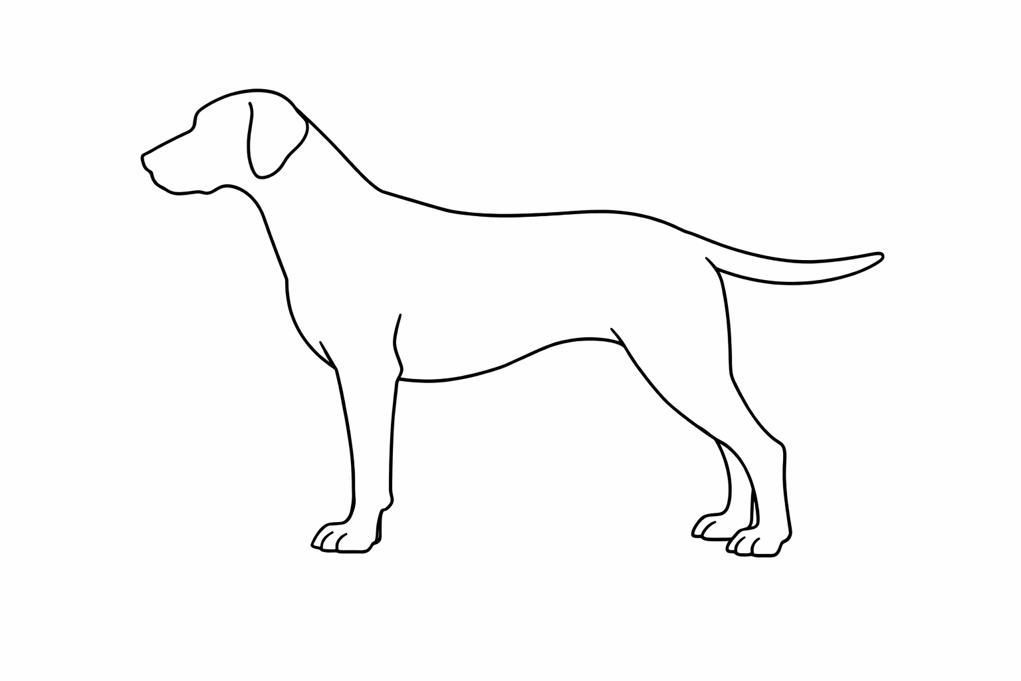
Write the name of the part identified by the letter:
- _________________ B. _________________
- _________________ D. _________________
- _________________ F. _________________
- _________________ H. _________________
G
H
F
E Joint, Upper Thigh, Thigh, Lower Thigh, Knee, Knee Joint, Stifle Joint, Hock, Rear Pastern, Hind Foot, Toenail, Buttocks, Tail, Tail Set
Hindquarters: Hip Joint, Upper Thigh, Thigh, Lower Thigh, Knee, Knee Joint, Stifle Joint, Hock, Rear Pastern, Hind Foot, Toenail, Buttocks, Tail, Tail Set

D
Hindquarters: Hip Joint, Upper Thigh, Thigh, Lower Thigh, Knee, Knee Joint, Stifle Joint, Hock, Rear Pastern, Hind Foot, Toenail, Buttocks, Tail, Tail Set

C: Hip Joint, Upper Thigh, Thigh, Lower Thigh, Knee, Knee Joint, Stifle Joint, Hock, Rear Pastern, Hind Foot, Toenail, Buttocks, Tail, Tail Set
Hindquarters: Hip Joint, Upper Thigh, Thigh, Lower Thigh, Knee, Knee Joint, Stifle Joint, Hock, Rear Pastern, Hind Foot, Toenail, Buttocks, Tail, Tail Set
C
B: Hip Joint, Upper Thigh, Thigh, Lower Thigh, Knee, Knee Joint, Stifle Joint, Hock, Rear Pastern, Hind Foot, Toenail, Buttocks, Tail, Tail Set
Hindquarters: Hip Joint, Upper Thigh, Thigh, Lower Thigh, Knee, Knee Joint, Stifle Joint, Hock, Rear Pastern, Hind Foot, Toenail, Buttocks, Tail, Tail Set

A: Hip Joint, Upper Thigh, Thigh, Lower Thigh, Knee, Knee Joint, Stifle Joint, Hock, Rear Pastern, Hind Foot, Toenail, Buttocks, Tail, Tail Set
Hindquarters: Hip Joint, Upper Thigh, Thigh, Lower Thigh, Knee, Knee Joint, Stifle Joint, Hock, Rear Pastern, Hind Foot, Toenail, Buttocks, Tail, Tail Set

Colorado State University Extension is an equal opportunity provider. Colorado State University Extension es un proveedor que ofrece igualdad de oportunidades.https://col.st/0WMJA

