Body and Topline Labeling
Label all anatomical structures.
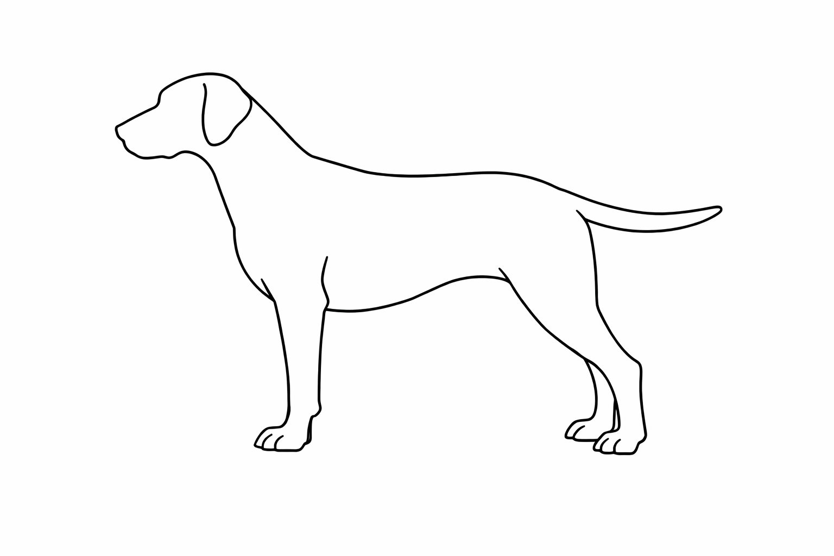
H
G
F
E Joint, Upper Thigh, Thigh, Lower Thigh, Knee, Knee Joint, Stifle Joint, Hock, Rear Pastern, Hind Foot, Toenail, Buttocks, Tail, Tail Set
Hindquarters: Hip Joint, Upper Thigh, Thigh, Lower Thigh, Knee, Knee Joint, Stifle Joint, Hock, Rear Pastern, Hind Foot, Toenail, Buttocks, Tail, Tail Set

D
Hindquarters: Hip Joint, Upper Thigh, Thigh, Lower Thigh, Knee, Knee Joint, Stifle Joint, Hock, Rear Pastern, Hind Foot, Toenail, Buttocks, Tail, Tail Set

C: Hip Joint, Upper Thigh, Thigh, Lower Thigh, Knee, Knee Joint, Stifle Joint, Hock, Rear Pastern, Hind Foot, Toenail, Buttocks, Tail, Tail Set
Hindquarters: Hip Joint, Upper Thigh, Thigh, Lower Thigh, Knee, Knee Joint, Stifle Joint, Hock, Rear Pastern, Hind Foot, Toenail, Buttocks, Tail, Tail Set
C
B: Hip Joint, Upper Thigh, Thigh, Lower Thigh, Knee, Knee Joint, Stifle Joint, Hock, Rear Pastern, Hind Foot, Toenail, Buttocks, Tail, Tail Set
Hindquarters: Hip Joint, Upper Thigh, Thigh, Lower Thigh, Knee, Knee Joint, Stifle Joint, Hock, Rear Pastern, Hind Foot, Toenail, Buttocks, Tail, Tail Set

A: Hip Joint, Upper Thigh, Thigh, Lower Thigh, Knee, Knee Joint, Stifle Joint, Hock, Rear Pastern, Hind Foot, Toenail, Buttocks, Tail, Tail Set
Hindquarters: Hip Joint, Upper Thigh, Thigh, Lower Thigh, Knee, Knee Joint, Stifle Joint, Hock, Rear Pastern, Hind Foot, Toenail, Buttocks, Tail, Tail Set

Write the letter to identify the part.

Croup __________ Flank __________ Withers __________
Abdomen __________ Loin __________ Backline __________
Belly __________ Back __________
Colorado State University Extension is an equal opportunity provider. Colorado State University Extension es un proveedor que ofrece igualdad de oportunidades. https://col.st/0WMJA

