Chapter 2 – Breeds Resource
These 20 common AKC breeds represent all seven AKC Groups and are excellent for skill-a-thons, lessons, and displays.

How I’d Use These…
✔ Breed ID practice
✔ AKC Group recognition
✔ Skillathon stations
✔ Classroom or barn displays
✔ Matching games and quizzes

Sporting Group
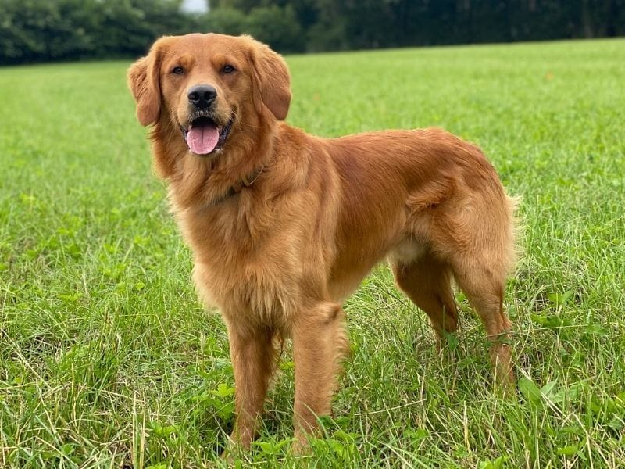

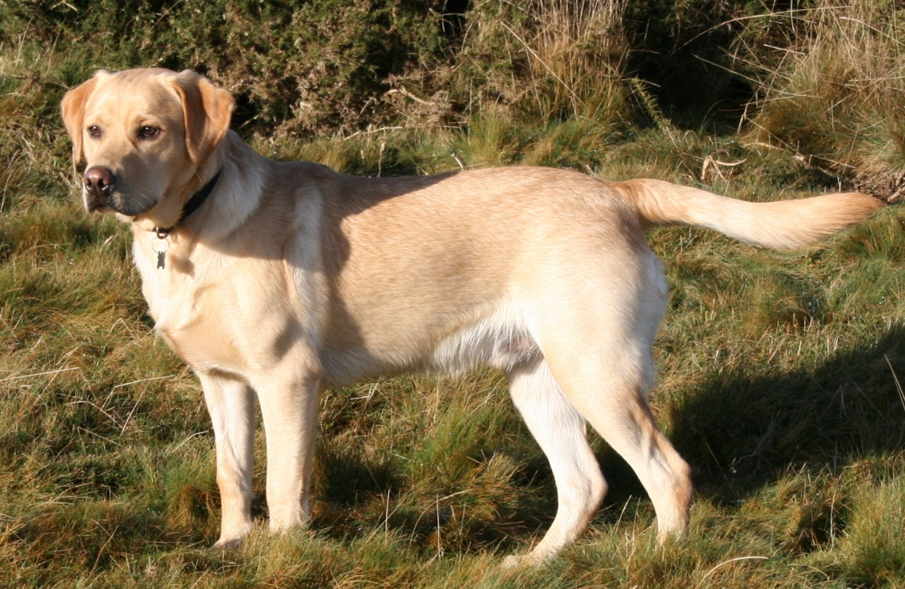

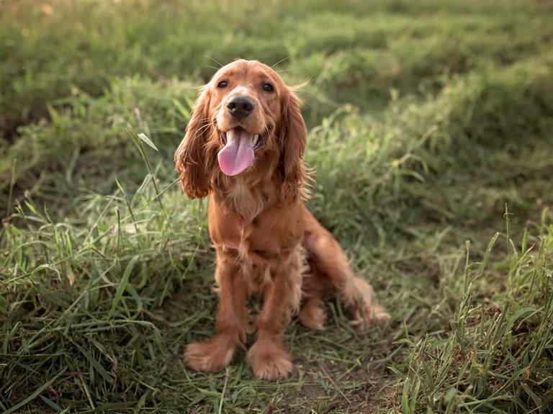
Breeds shown:
- Labrador Retriever
- Golden Retriever
- Cocker Spaniel
Teaching focus:
Bred to hunt and retrieve game; athletic and people-oriented.

Hound Group
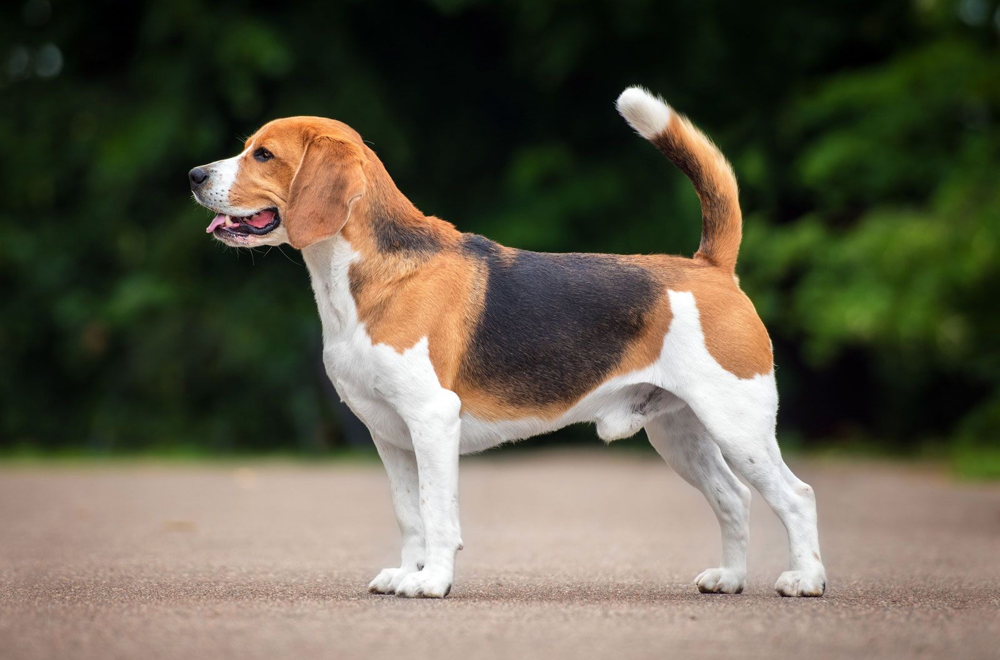

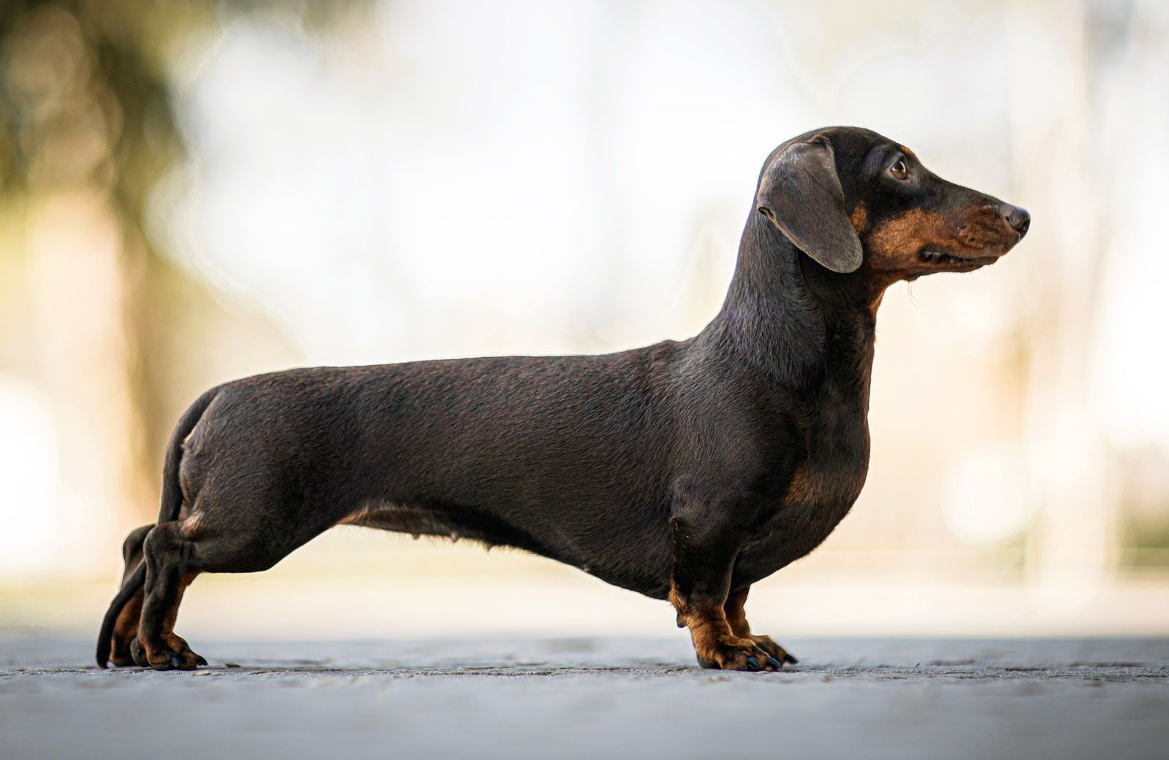
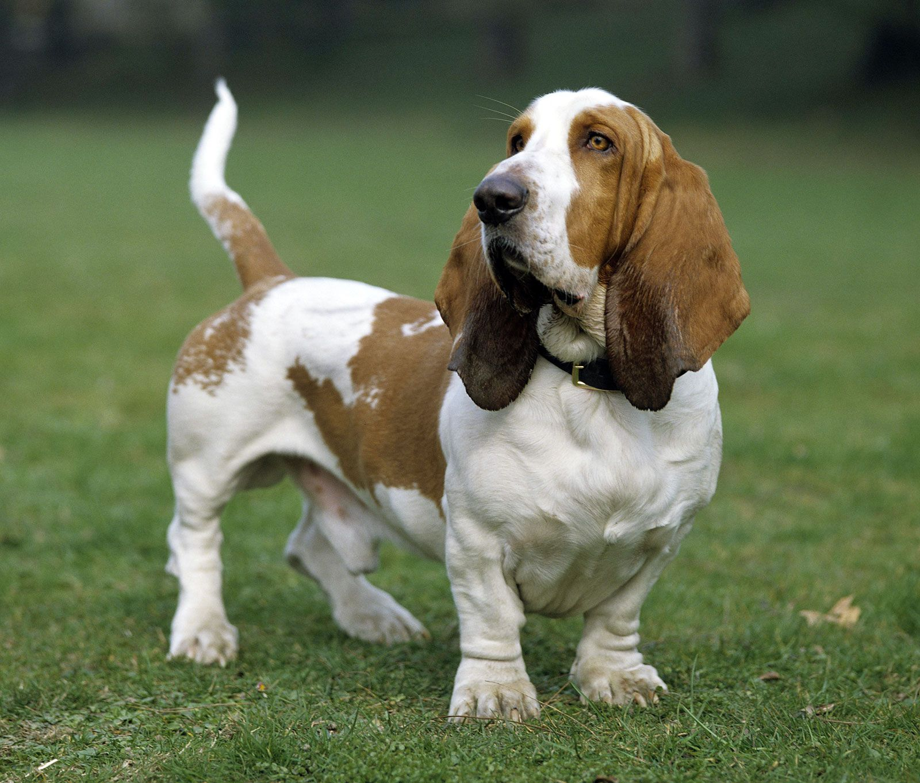
Breeds shown:
- Beagle
- Dachshund
- Basset Hound
Teaching focus:
Hunt by scent or sight; strong instincts and determination.

Working Group
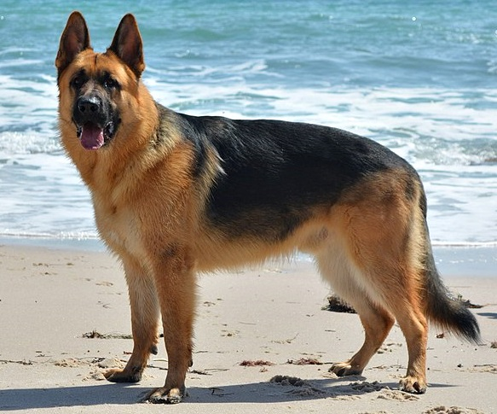

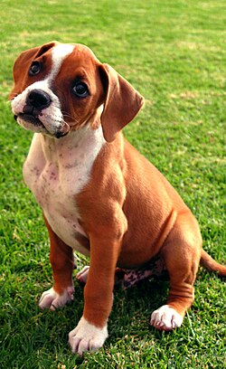
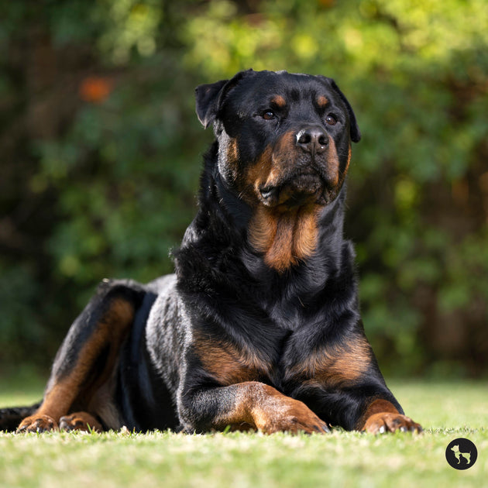
Breeds shown:
- German Shepherd Dog
- Boxer puppy
- Rottweiler
Teaching focus:
Developed for guarding, protection, and service work.

Terrier Group
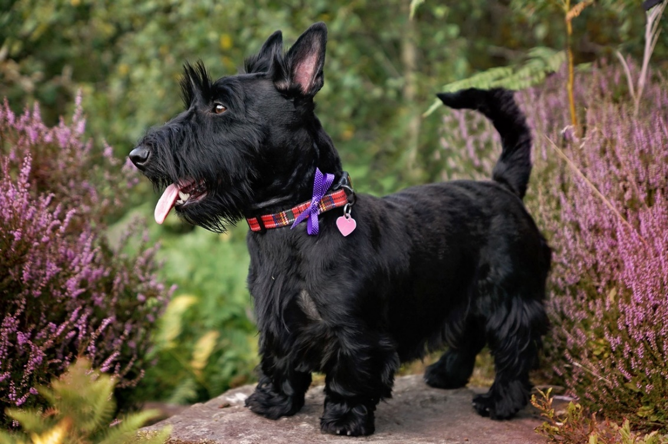

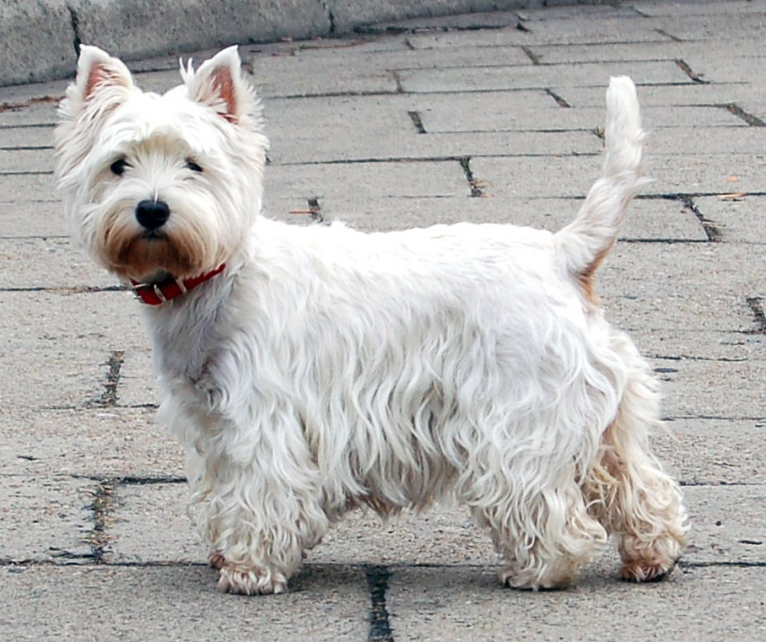
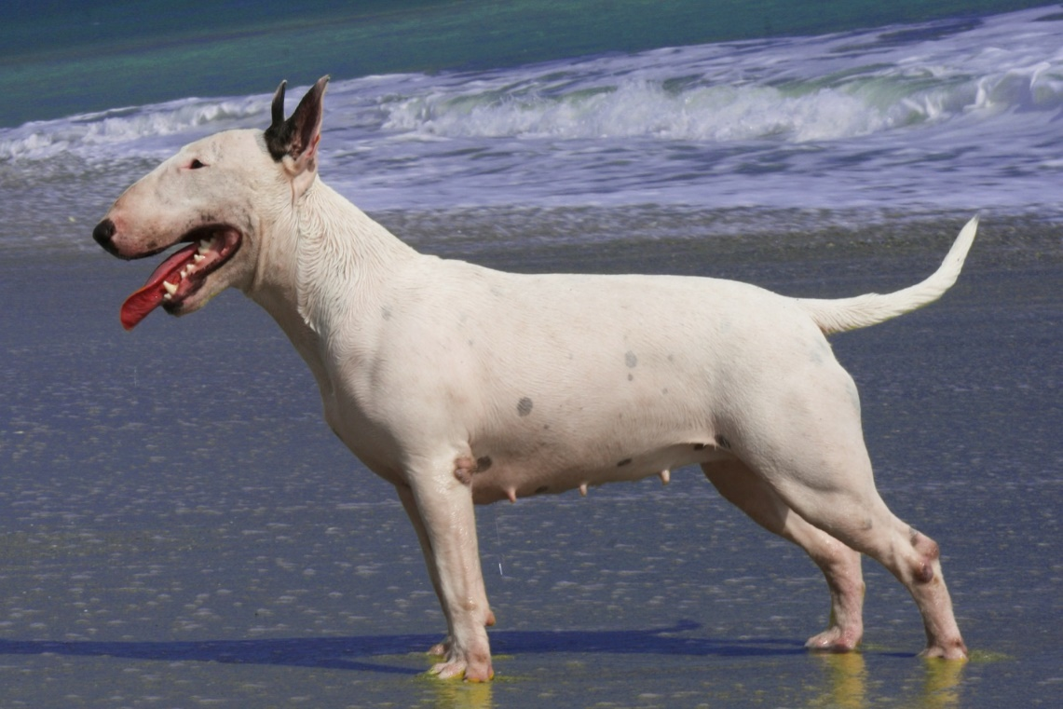
Breeds shown:
- Scottish Terrier
- West Highland White Terrier
- Bull Terrier
Teaching focus:
Bred to hunt vermin; bold, energetic, and determined.

Toy Group
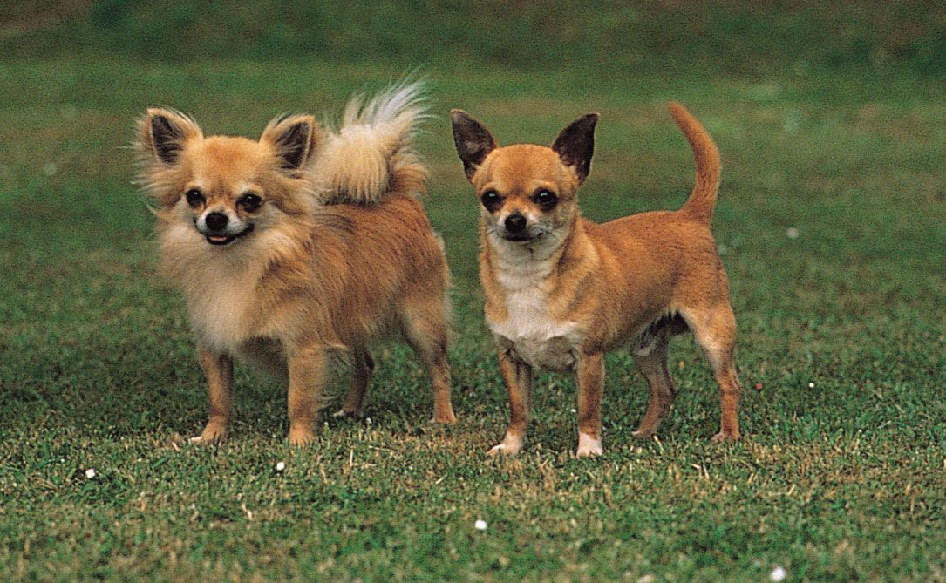

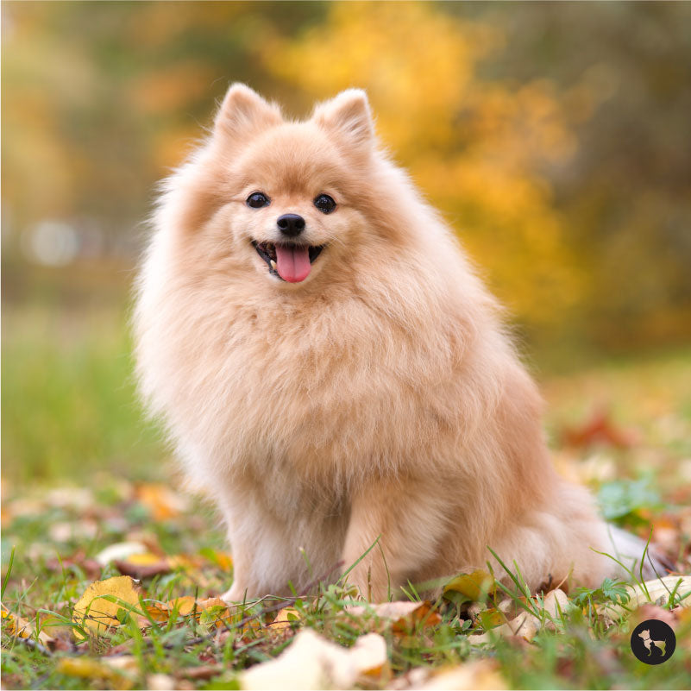
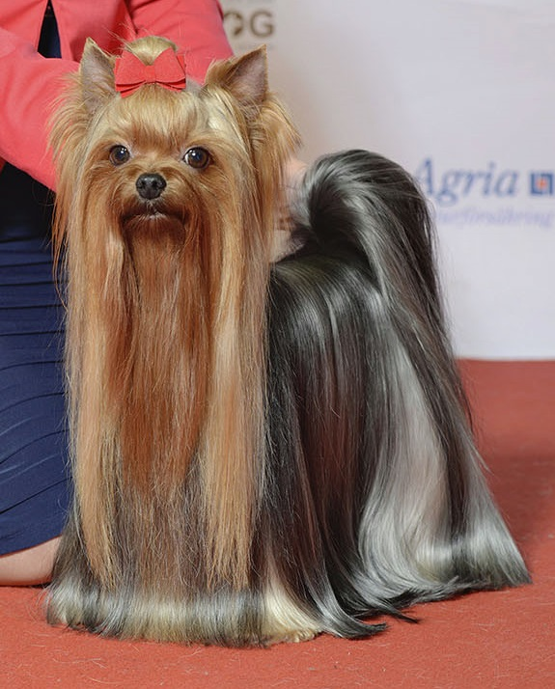
Breeds shown:
- Chihuahua. Long and short hair
- Pomeranian
- Yorkshire Terrier
Teaching focus:
Companion breeds; small size with big personalities.

Non-Sporting Group
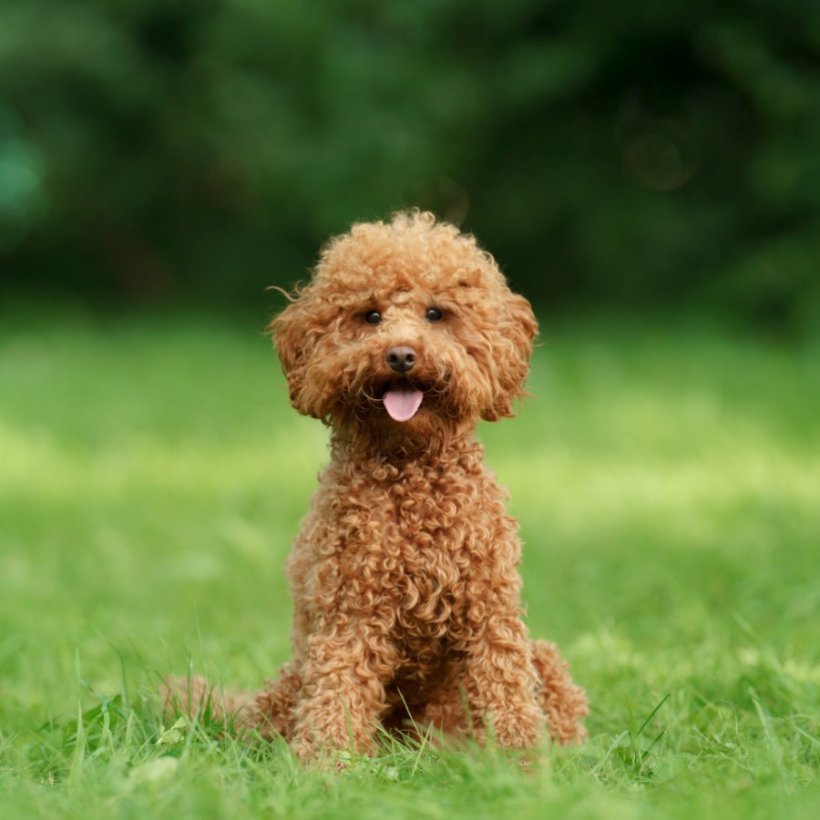

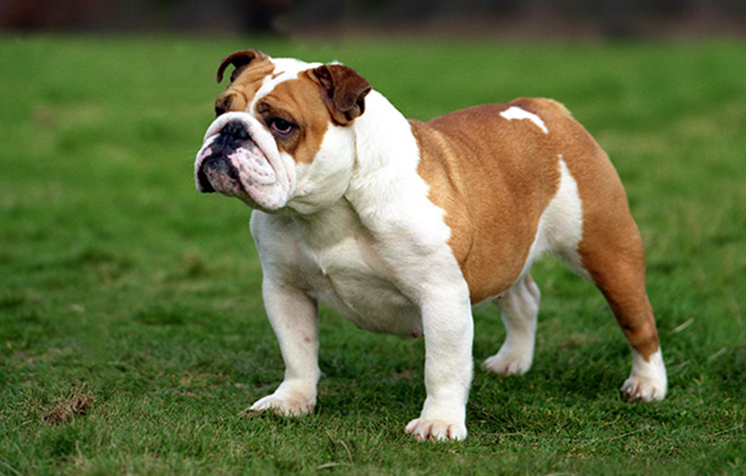
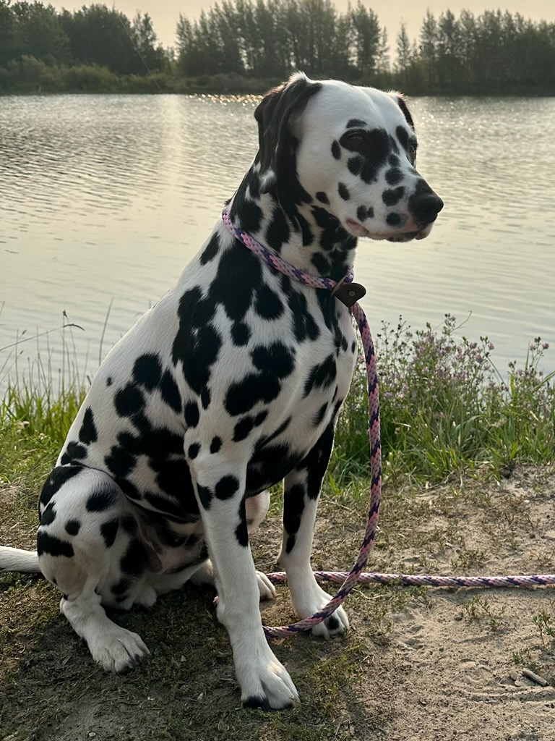
Breeds shown:
- Poodle puppy
- Bulldog
- Dalmatian
Teaching focus:
A diverse group with many sizes, purposes, and temperaments.

Herding Group
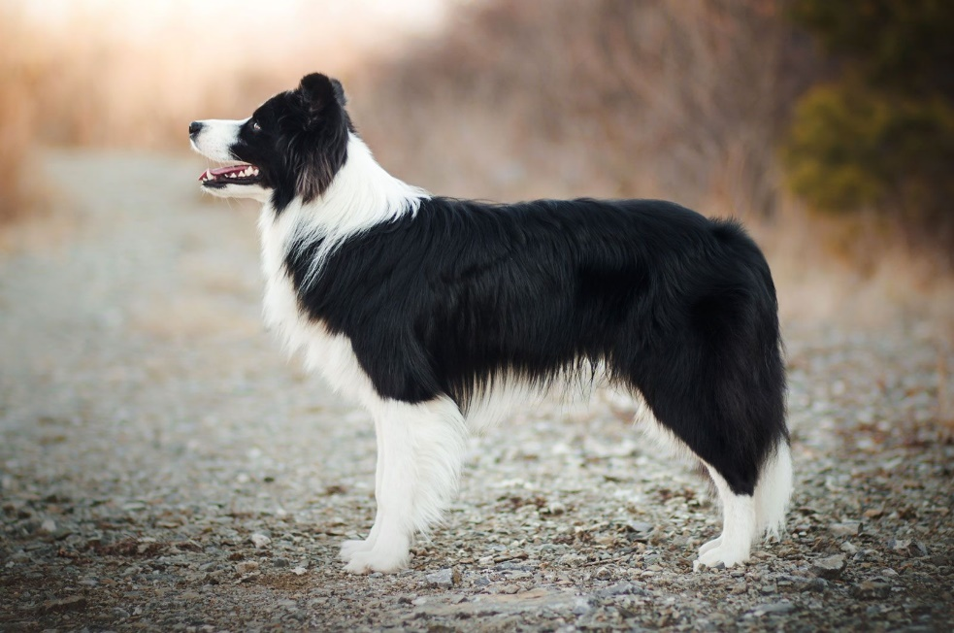

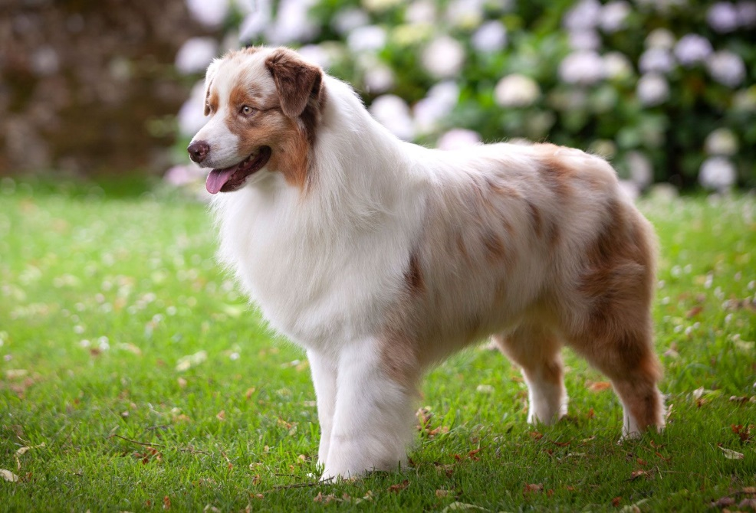
Breeds shown:
- Border Collie
- Australian Shepherd
Teaching focus:
Bred to control livestock using intelligence and movement.
Colorado State University Extension is an equal opportunity provider. Colorado State University Extension es un proveedor que ofrece igualdad de oportunidades. https://col.st/0WMJA

