Types of Skulls
Identify how each skull is different and name the skull.
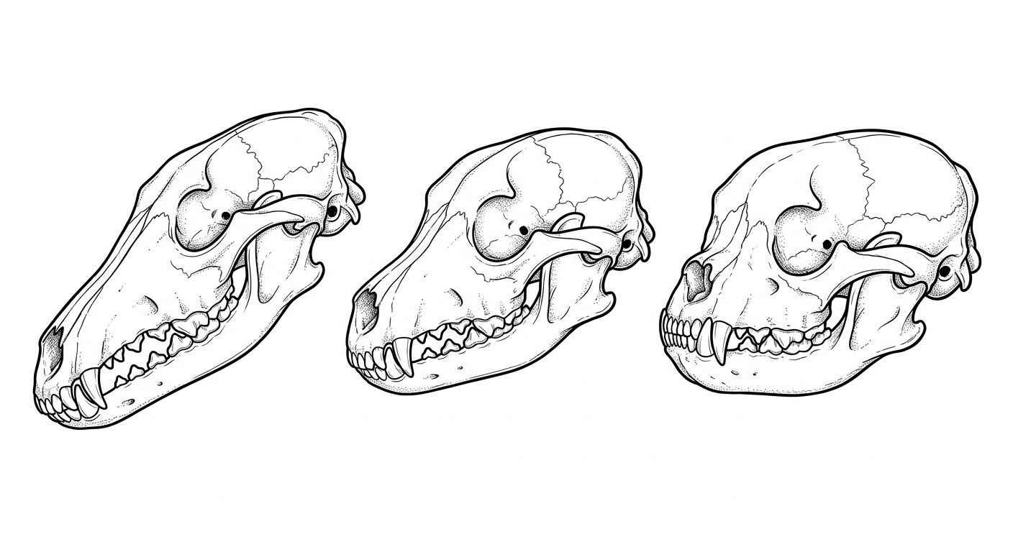
B
C
A
- ________________________________________________________________________________
________________________________________
- ________________________________________
________________________________________
________________________________________
- ________________________________________
________________________________________
________________________________________
Colorado State University Extension is an equal opportunity provider. Colorado State University Extension es un proveedor que ofrece igualdad de oportunidades. https://col.st/0WMJA

