Chapter 16 Health

🟢 Skill-a-thon Station 1

Veterinary/Client/Patient Relationship (VCPR)

🛠 Station Setup
Display:
- A mock veterinary invoice
- A vaccination certificate
- A blank health plan form

📝 Youth Task
Review the materials and answer the following questions.

Questions
- What does VCPR stand for?
- What must occur for a valid VCPR to exist?
- Why is a VCPR important for animal welfare?
- Can a veterinarian prescribe medication without a VCPR? (Yes/No)

✅ Answer Key
- Veterinary/Client/Patient Relationship
- The veterinarian must examine the dog and discuss a health plan
- It ensures proper medical care, monitoring, and legal compliance
- No
🟢 Skill-a-thon Station 2

Internal Parasite Identification
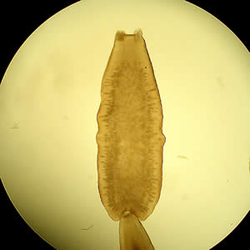
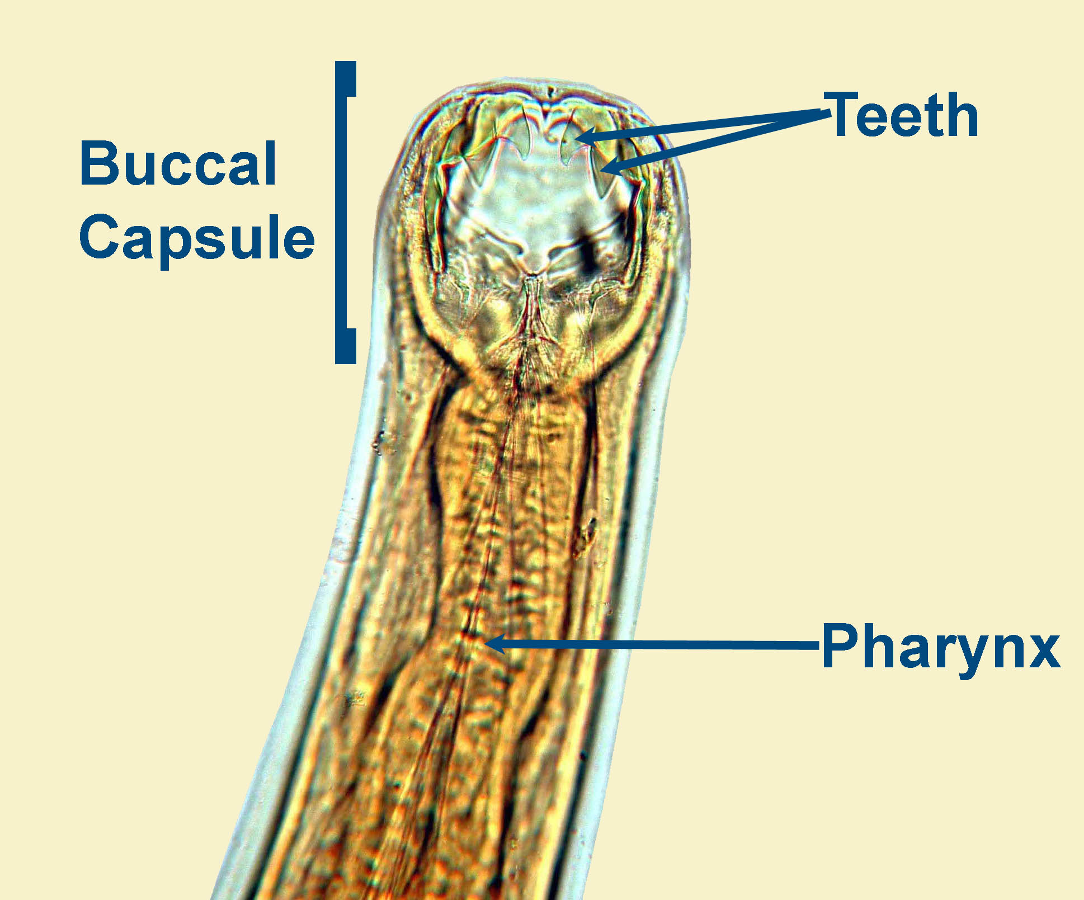
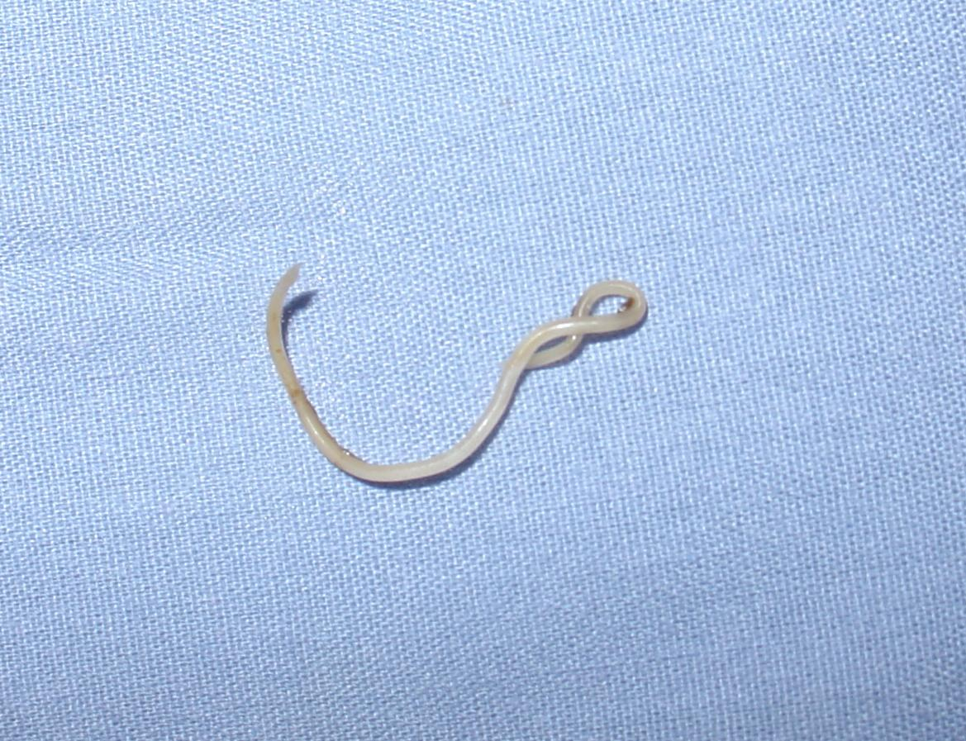
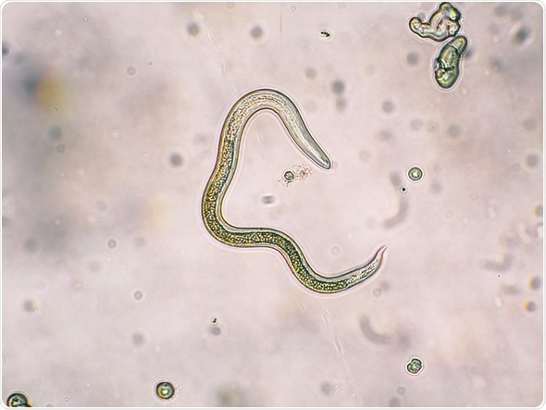

🛠 Station Setup
Display labeled images of:
- Tapeworm (D. caninum)
- Hookworm (Ancylostoma caninum)
- Roundworm (Toxocara canis)
- Whipworm (Trichuris vulpis)

📝 Youth Task
Identify each parasite and answer questions.

Questions
- Which parasite is transmitted through fleas?
- Which parasite can penetrate human skin?
- Which parasite causes a pot-belly appearance in puppies?
- Which parasite attaches to the small intestine and sheds rice-like segments?

✅ Answer Key
- Tapeworm (D. caninum)
- Hookworm
- Roundworm
- Tapeworm

🟢 Skill-a-thon Station 3

Zoonotic Disease Prevention

🛠 Station Setup
Display:
- Handwashing poster
- Photo of child playing in sandbox
- Flea control product
- Pooper scooper

📝 Youth Task
Determine correct prevention strategies.

Questions
- What is the single best method to prevent disease transmission?
- Why are children at higher risk for zoonotic infection?
- Name two parasites that can infect both dogs and humans.
- Why is flea control critical in zoonotic prevention?

✅ Answer Key
- Hand washing
- They may ingest contaminated dirt or fleas
- Roundworms, Hookworms, Tapeworms, Giardia
- Fleas transmit tapeworms

🟢 Skill-a-thon Station 4

Vaccination & Wellness Planning
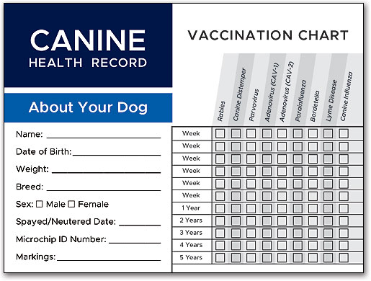
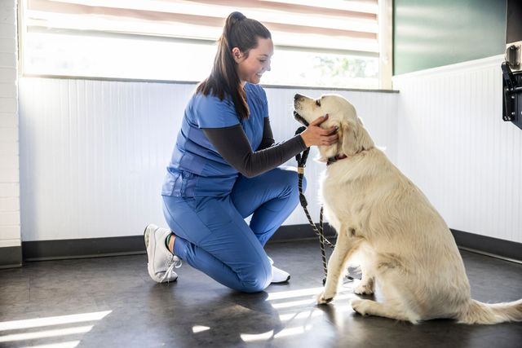
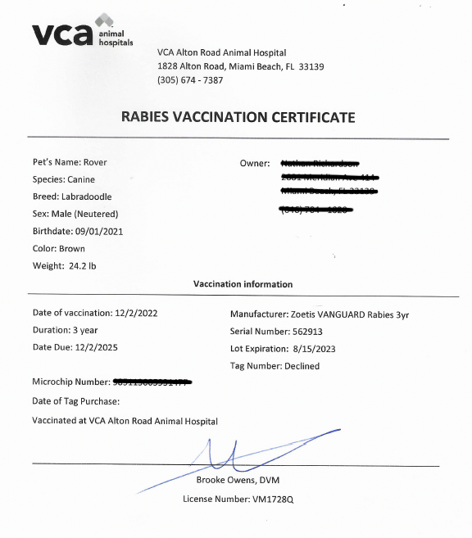
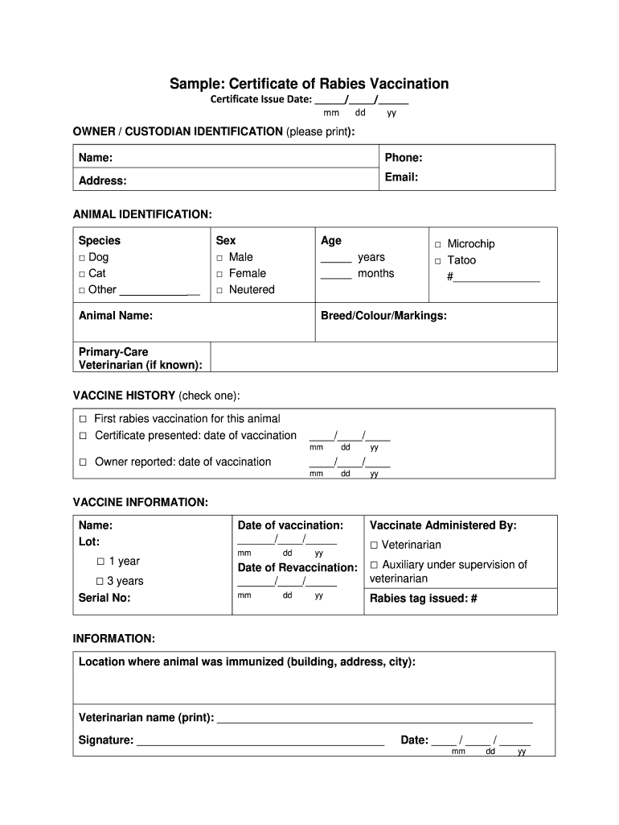

🛠 Station Setup
Provide:
- Sample vaccination schedule
- Rabies certificate
- Wellness checklist

📝 Youth Task
Review the documents and answer.

Questions
- Which vaccination is required by law?
- At what age is rabies typically first administered?
- What are core vaccines?
- List three components of a year-round wellness program.

✅ Answer Key
- Rabies
- At least 12 weeks of age
- Vaccines recommended for all dogs
- Examples: parasite prevention, annual exam, dental care, nutrition monitoring

🟢 Skill-a-thon Station 5

Recognizing a Healthy vs. Unhealthy Dog
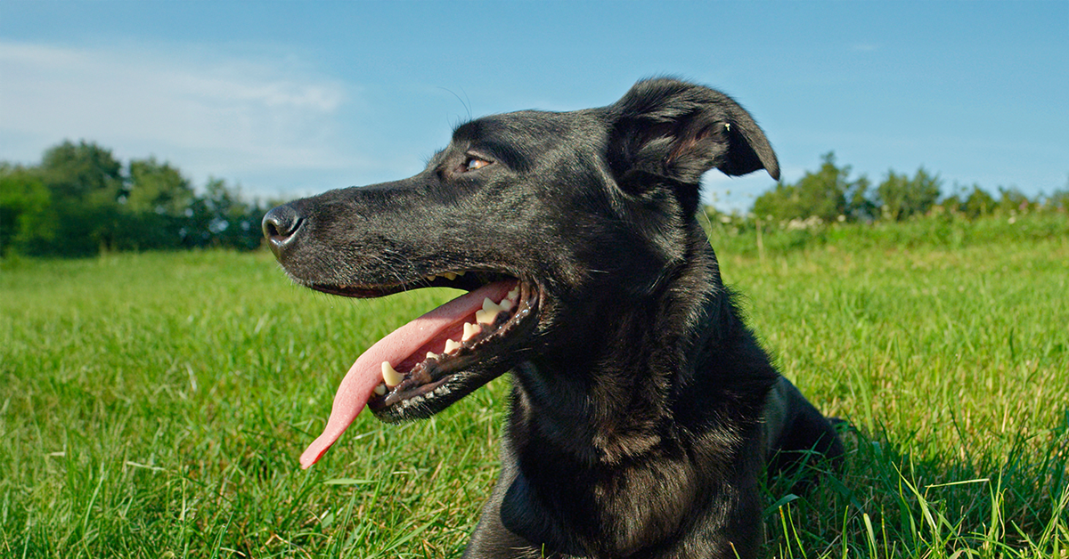
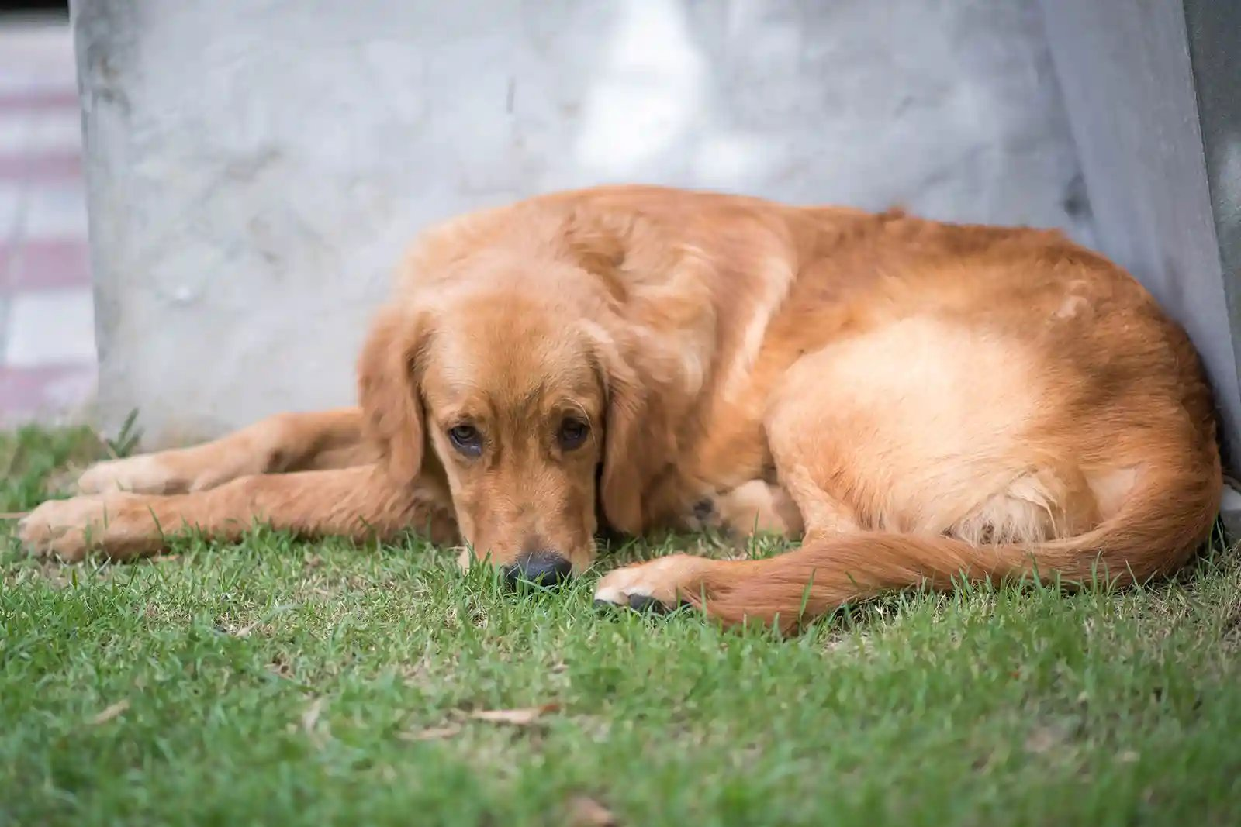
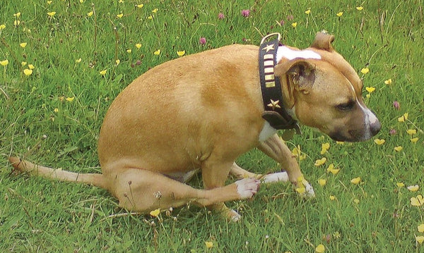
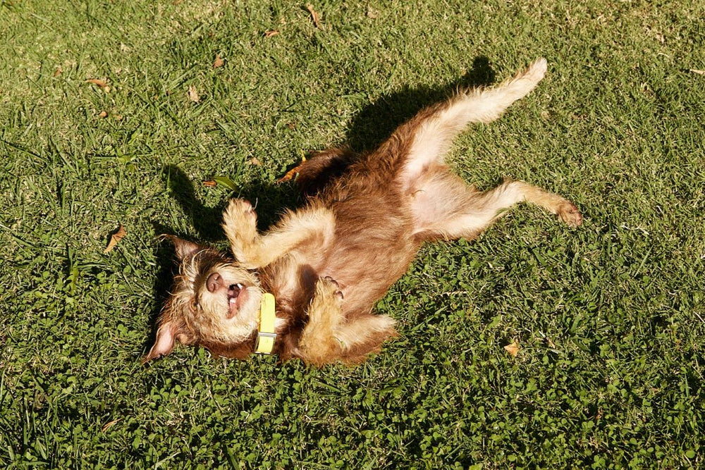

🛠 Station Setup
Display images of:
- Healthy dog
- Dog scooting
- Dog with pale gums
- Dog with dull coat

📝 Youth Task
Determine health status and possible cause.

Questions
- List three signs of a healthy dog.
- What might scooting indicate?
- What could pale gums suggest?
- Why is regular physical examination by the owner important?

✅ Answer Key
- Bright eyes, alert behavior, normal appetite, clean coat
- Possible tapeworm infestation
- Possible anemia or illness
- Early detection of disease

Colorado State University Extension is an equal opportunity provider. Colorado State University Extension es un proveedor que ofrece igualdad de oportunidades. https://col.st/0WMJA

