Head and Neck Labeling Diagram
Label all anatomical structures listed in the term bank.

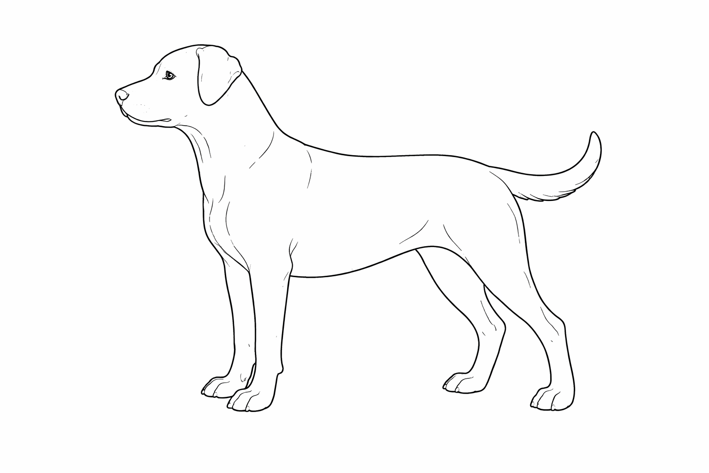
Term Bank: Head & Neck: Crown, Occiput, Leather, Ear, Eye, Cheek, Stop, Muzzle, Nose, Flew, Upper Lip, Lower Lip, Lower Jaw, Nape, Crest, Neck, Throat
Colorado State University Extension is an equal opportunity provider. Colorado State University Extension es un proveedor que ofrece igualdad de oportunidades. https://col.st/0WMJA

