Neck and Throat
Match the description with the part and label the part on the dog.

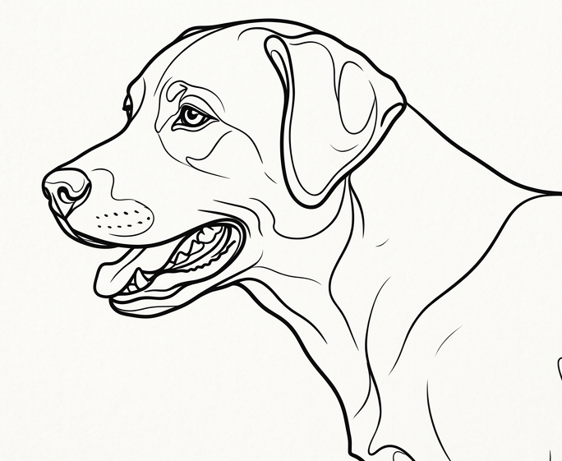

- Nape connects head to body
- Crest top line of the neck
- Neck underside of neck
- Throat back of the neck

