Head Structure Practice
Place the number to identify the part.

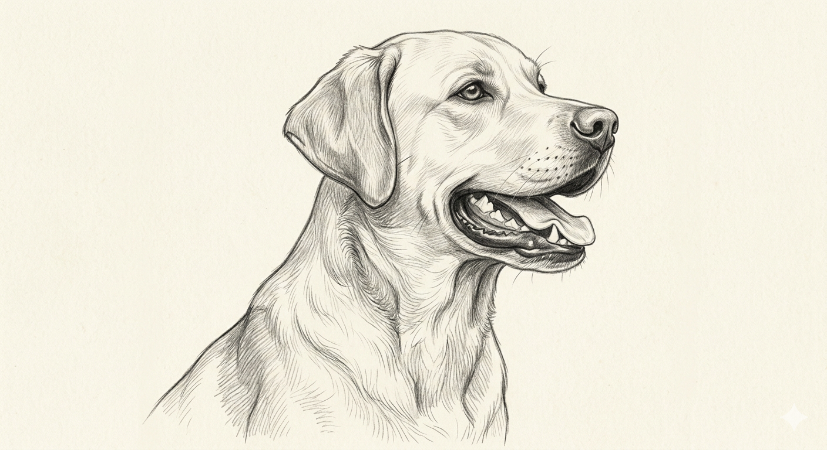

- Crown – top of the skull between the ears
- Occiput – back of the skull
- Leather
- Ear
- Cheek
- Stop
- Eye
- Muzzle
- Nose
- Flew / Upper lip
- Lower lip
- Lower jaw (mandible)

Colorado State University Extension is an equal opportunity provider. Colorado State University Extension es un proveedor que ofrece igualdad de oportunidades. https://col.st/0WMJA

