Head Structure
Practice

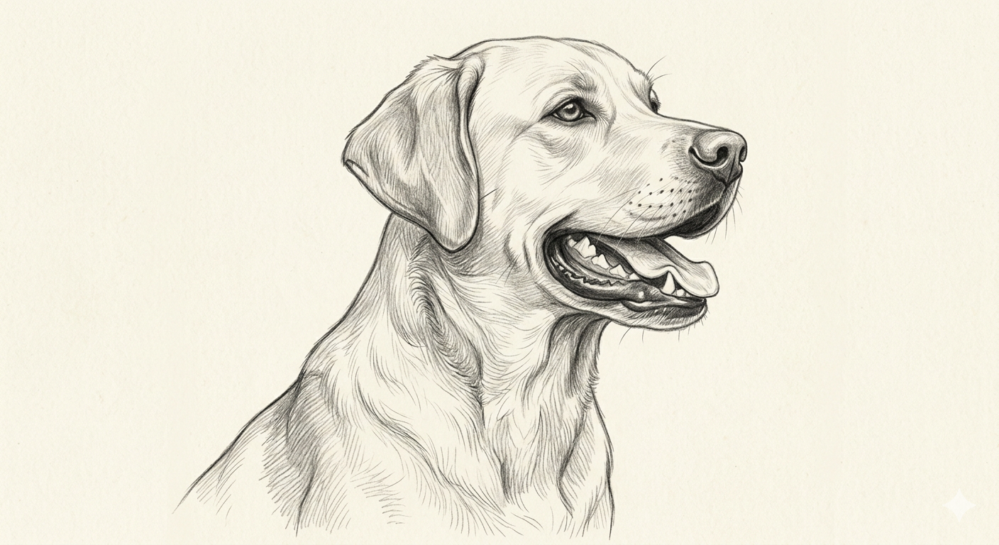

Label each part then draw a line from the part you named to the description.

- __________________________ 1. Top of the skull between the ears

- __________________________ 2. Organ of vision

- __________________________ 3. Side of face

- __________________________ 4. Back of skull

- __________________________ 5. Organ of hearing and expression

- __________________________ 6. Lower edge of the mouth

- __________________________ 7. Front portion of the face

- __________________________ 8. Movable jaw bone

- __________________________ 9. Hanging portion of the upper lip

- __________________________ 10. Back of the skull

- __________________________ 11. Between muzzle and skul

- __________________________ 12. Flexible outer ear

