
State 4-H Dog Trials Internship Application

The State 4-H Dog Trials is the premier 4-H dog show for Colorado. Running the show takes many hands so we are opening up volunteer positions for youth internships during the show, which is held at the Colorado State Fairgrounds in Pueblo in August. NO experience is necessary. We will train you!

Qualifications
- Senior 4-H member in good standing between the ages of 14 and 18
- Ability to learn tasks quickly and perform them as directed while at the show
- Table Steward: Experience with Google Sheets and Docs

Position Descriptions
You may choose from the following roles:
- Ring Steward – The Ring Steward’s job is to help keep the ring running smoothly so the judge can focus on scoring! Ring Steward jobs may require time keeping, jump-setting, posts for the figure 8, course changing, maintaining the ring, and other duties as assigned by the judge. Running the “Go Board” requires locating and keeping exhibitors lined up and organized
  - Time Required: 8:30am for volunteer meeting through the end of the show day, usually around 5:00pm.
  - We need 14 stewards on Saturday and 10 on Sunday.
- Table Steward – The Table Steward’s job requires experience and will do real time score reporting at the ring. Table stewards will manage scoresheets, enter data into Google Sheets or Docs, assist with timing, identify ties and runoffs, and provide specific assistance as required by the judge.
  - Time Required: 8:30am for volunteer meeting through the end of the show day, usually around 5:00pm.
  - We need 7 stewards on Saturday and 5 on Sunday.
- Float Steward - Pick up score sheets from each ring and deliver to Tabulation. Pick up ribbons from Tabulation and deliver to the correct ring. Assist with award hand out, if needed. Cover any bathroom breaks. Assist with snack/food setup and take down.
  - Time Required: 8:30am for volunteer meeting through the end of the show day, usually around 5:00pm.
  - We need one Float Steward per day.

Expectations
- Interns will meet on Zoom before the show for an orientation.
- Interns need to travel to Pueblo the weekend of the State 4-H Dog Trials (Aug. 15-17, 2025).
- Interns are expected to help with cleanup at the end of the show each day.
- If staying overnight on Friday before the show to help with setup or on Saturday, interns must stay with a parent/guardian in a hotel or, if driving themselves, they can stay in the Growing Minds Dorm on the Colorado State Fairgrounds, which provides free accommodations. (Note: The state 4-H office cannot cover hotel expenses. We can cover mileage for interns traveling to the state dog trials who are NOT also competitors in the dog trials.)
- If dropped off, interns must be picked up on Sunday late afternoon after show cleanup and awards.

Benefits
Interns at the State 4-H Dog Trials will learn the inner workings of managing a dog show. They will build relationships with adult volunteers and Extension staff while assisting other 4-H youth to have a quality experience showcasing the skills they have acquired while working with their dog(s). They will have the opportunity to learn what judges look for in various dog showing disciplines. Breakfast and lunch will be provided. If you stay in the Growing Minds Dorms, dinner will also be provided in the 4-H Dining Hall on Saturday evening, or you can DoorDash food from town. If you are with a parent/guardian, you can go off the fairgrounds to eat dinner.

Supervisor/Mentors
- Anna Parrish, State 4-H Dog Trials Volunteer Superintendent
- Dawn Sanchez, State 4-H Animal Science Specialist
- Lisa Sholten, State 4-H Civic Engagement & Curriculum Specialist

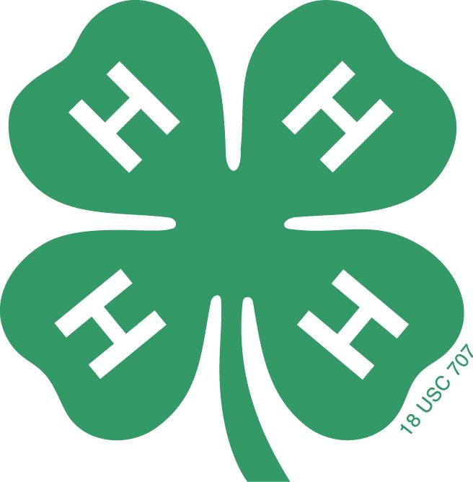

Colorado State University Extension is an equal opportunity provider. | Colorado State University Extension es un proveedor que ofrece igualdad de oportunidades.
Colorado State University does not discriminate on the basis of disability and is committed to providing reasonable accommodations. | Colorado State University no discrimina por motivos de discapacidad y se compromete a proporcionar adaptaciones razonables.

CSU’s Office of Engagement and Extension ensures meaningful access and equal opportunities to participate to individuals whose first language is not English. | Office of Engagement and Extension de CSU garantiza acceso significativo e igualdad de oportunidades para participar a las personas quienes su primer idioma no es el inglés. Col.st/ll0t3
State 4-H Dog Trials Intern Application Form

Date:_________________________ County:____________________________
Name_______________________________________________________________________
Phone (Cell)________________________ (Home)______________________
Email__________________________________ Number of years as a 4-H member_________

Which type of internship role(s) do you prefer?
- Ring Steward
- Table Steward
- Float Steward

Are you enrolled in the Dog Project? Note: This is not a requirement to be an intern.

___________Yes ___________No

Would you need to stay in the dorms? (Exceptions to staying in the dorms are allowed for 4-H interns who live in the Pueblo vicinity or who are traveling with parents.)

___________Yes ___________No

Applicant Signature:

____________________________________________________________________________
Name Date

Parent/Guardian Signature:

____________________________________________________________________________
Name Date

Signature of County 4-H Specialist/Coordinator’s or 4-H Leader who is recommending you:

____________________________________________________________________________
Name Title Date

Submission of an application does not mean you have been selected to serve as an intern. You will be interviewed over Zoom by a State 4-H Specialist, the Volunteer Superintendent and any other Superintendent from the State 4-H Dog Advisory Committee before your internship is approved. Contact Anna Parrish at anna4hleader@gmail.com with questions.

