

Medication Label Handout
(To be used with MQA Activity 4)

Medication labels have 8 items that you need to pay attention to. The following label shows those parts:

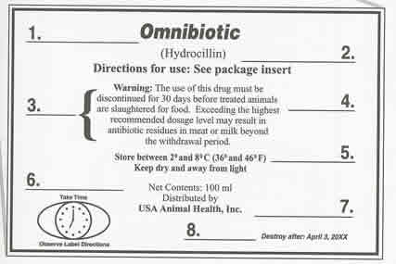 | 1. Name of Drug  2. Active Ingredient  3. Cautions/Warnings  4. Withholding Time  5. Storage  6. Quantity of Contents  7. Name of Distributor

Additionally, all medications have inserts that contain similar information, but also, a lot more in-depth information. The following figure shows what is on a medication insert:
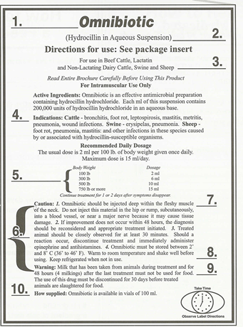 | 1. Name of Drug  2. Active Ingredient  3. Species  4. Approved Use  5. Dosage  6. Cautions/Warnings  7. Route of Administration  8. Storage  9. Withholding Times  10. Sizes Available

Storage:
Medications will vary with how they need to be stored and for how long they are effective. Some will require refrigeration while others can be stored at room temperature. Some medications will say “use entire bottle” meaning that once the bottle is opened, it must be used or discarded as it will lose its effectiveness. All medications will have their storage directions on the label. ALWAYS READ THE MEDICATION LABEL – the labels will tell you all the essential information about the medicine. Keep an inventory list of all medication to facilitate proper storage.

*supplement Updated 1-4-19

