Colorado 4-H Club
Treasurer Book

Club:

Treasurer:

Club Leader:

Year:

County:

Colorado State University, U.S Department of Agriculture and Colorado counties cooperating. To simplify technical terminology, trade names or products and equipment occasionally will be used. No endorsement of product names is intended nor is criticism implied of products not mentioned.

Colorado State University Extension is an equal opportunity provider. Colorado State University does not discriminate on the basis of disability and is committed to providing reasonable accommodations. CSU’s Office of Engagement and Extension ensures meaningful access and equal opportunities to participate to individuals whose first language is not English. https://col.st/0WMJA

Colorado State University Extension es un proveedor que ofrece igualdad de oportunidades.Colorado State University no discrimina por motivos de discapacidad y se compromete a proporcionar adaptaciones razonables. Office of Engagement and Extension de CSU garantiza acceso significativo e igualdad de oportunidades para participar a las personas quienes su primer idioma no es el inglés. https://col.st/0WMJA
This complete 4-H Treasurer Book and all the supplemental forms are available online at: http://co4h.colostate.edu/volunteer-resources/club-group-resources/

USDA requires that 4-H clubs, councils and foundations file financial statements and fundraising plans with Colorado State University Extension annually. 4-H youth need a simple reporting structure to demonstrate the financial value of 4-H's contributions.
This 4-H Treasurer's Book was originally published by the University of Michigan and has been adapted for Colorado 4-H. This book has been used successfully by 4-H programs in many states. It meets a variety of fiscal accounting needs and is designed for 4-H club treasurer and adult volunteers, as well as for 4-H youth interested in learning the basics of good accounting practices.

Updated January 2019, February 2023
About Being an Officer

You, as the treasurer, and all the other officers of your 4-H club are representatives of your 4-H club or group and the 4-H program throughout the state. Your skills, abilities, values, standards, ideals, speech and smiles represent Colorado 4-H.

About Being the Treasurer

This section should be reviewed with your club leader. You should also review and discuss the book “4-H Finances: Accountability and Reporting" online at www.colorado4h.org. The treasurer is responsible for taking care of the club’s money and bank accounts. This responsibility requires honesty, integrity, cooperation and communication with the members of your club.

The Treasurer’s Responsibilities

Check the following items to verify that you understand and accept these responsibilities:

- I will inform the bank in which my 4-H club’s funds are deposited that I am the new treasurer and sign the appropriate forms so I can write checks on the account.

- I will handle all money matters for my 4-H club.

- I will keep an accurate record in the treasurer's book of how all the money is used.

- I will deposit all funds that my group earns or receives in the bank as soon as possible after receiving them.

- I will pay all of the group's bills promptly as directed by the members and approved by the president.

- I will prepare and present a summary of income and expenses at each meeting.

- I will report the current balance of all accounts.

- I will complete the Project Budget/Fundraising plan and Annual Summary Financial Plan at the end of the year and submit the report to the County Extension office.

Handling Money

4-H clubs are public groups, open to all without regard to race, color, national origin, gender, disability, religion or age. The money that clubs receive from dues and fund-raising events are the assets of the club, not the assets of any one member or leader of the group. Because 4-H is a public organization, it is not “owned” by individuals the way a company is owned. Instead, 4-H is owned by the public. Therefore, the responsibilities of the 4-H club treasurer are different from those of the treasurer of a private company.

A treasurer in a privately-owned company is responsible to the other officers of the company and to the owners or stockholders for managing and controlling the assets of the company. These assets include cash, bank accounts, buildings, land and equipment.
The treasurer of a 4-H group is accountable to the club officers, to the club members, adult leaders, County Government, Colorado State University Cooperative Extension and the Federal Government.

You’re in charge of “keeping the books”: that is, the club’s receipt book, checkbook and check register, payment vouchers and bank statements. The public calls for a higher standard of accountability and integrity for public groups. You can meet the high standards required of a 4-H treasurer by learning and following the money handling methods found in this treasurer’s book. These standards apply whether a club has 25 cents or $2500 dollars in the treasury.

Conflicts will arise if money is not handled carefully and accurately. You can protect yourself and your 4-H club from conflict by being careful, responsible and accurate when handling the club finances. If your club does not have a tax identification number, you should take the steps to get one. Go to the “4-H Finances: Accountability and Reporting” online at http://www.colorado4h.org/agent_resources/4hClubFinancialReport.pdf
Receipts

When you receive money from dues or a fund-raising activity, you must always write a receipt for it. Writing a receipt takes a little time, but it helps protect your reputation. Without a receipt there is no way to prove that your 4-H club received a specific amount of money or that you handled it correctly.

Figure 1. Sample Receipt
Date: June 22, 2023 | No. 8668
Received from: Lindsay Jones
Amount: $ 15.00 √ Cash Check
For: Baseball Tickets
By : Kyle Smith

Your 4-H group should have a receipt book with pre-numbered, two-part receipts. (They are available from any office supply store). If you make a mistake and have to void a receipt for any reason, mark both copies “VOID,” staple them together and keep them with the Treasurer’s record. (See fig. 1 for a sample receipt)
Receipts for Money From Fundraisers

If your 4-H club holds a fund-raiser such as a bake sale or car wash, you don't need to write a receipt for each person buying a cookie or having his/her car washed, but you (or the shift leader) need to write one at the end of each shift or at the end of the day. Each group of workers must account for the money they have received.

Two people from separate families should count the money, agree on the amount and turn the money over to you. It's a good idea for you to verify the amount (recount the money) in the presence of the individuals giving you the money. You could receive this in cash or checks or a combination of cash and check. Then give them a receipt for the amount they gave you. (see fig 2).

Figure 2. Receipt for money received from a fundraiser.

Date: November 12, 2023 | No. 8670
Received from: Carol Jones
Amount: $ 25.00 √ Cash √ Check
For: Selling Turkey Candles
10.00 in cash, 15.00 check
By : Kyle Smith

Bank Deposits

Checks that are made payable to the club must be endorsed by signing the club name and your name. If someone writes a check payable to you that is intended for your club, endorse it by writing “pay to the order of (your club’s name)” and signing it.
Keep these things in mind when making deposits:

•Deposit all funds promptly. If your group receives more than $10 at any time, deposit the money within three days.
•Endorse checks immediately when you receive them.

Preparing Deposits

Total the receipts you have written since you made the last deposit and compare that amount with the amount of cash, coins and checks you intend to deposit. The two figures should agree. If they don’t, repeat the process. When the two figures do agree, prepare a deposit ticket similar to figure 3. If your group has a checking account, there is a supply of deposit slips at the end of each pad of checks. You also might be able to pick up a slip in the bank lobby.

Follow these steps when filling out a deposit slip.

- Date the deposit slip.
- Fill in the amount of currency (bills) and coins you are depositing.
- List each check number and its amount separately using the back of the slip if necessary.
- Record the deposit in the checking account register.
- Complete a duplicate of the deposit slip and keep the duplicate with the bank receipt.

Figure 3. Sample Deposit slip
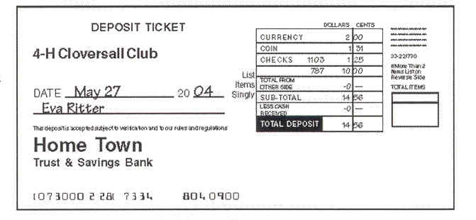

Approving and Paying Bills

Part of your treasurer’s report is asking for, and receiving, the approval of club members to pay outstanding bills. After the members approve paying the bills, write a check for the approved amount for each bill.

The usual way to pay bills is with a check. Holding cash back from deposits and then using the cash to pay bills is NOT a good practice because it doesn’t leave a record or provide proof of payment. A proper receipt protects your reputation as treasurer.
Matching Bills and Checks

- Every check written should have a receipt available in the file that shows the amount paid, the check number and the check date. For example, if a payment is made directly to Big Warehouse Store for tables, the receipt from Big Warehouse Store should be attached with the notation “Paid $142.38, 9/29/18, check #721.”
- If a check is written to an individual to reimburse that person for expenditures made on behalf of the club, copies of the appropriate receipts must be attached. The information listed on the copy of the receipt should indicate amount, date and check number as indicated in #1 above. A notation on the “memo” line of the check is not sufficient documentation.
- If an individual is reimbursed for multiple items with one check, each of the receipts should reflect the appropriate information (i.e., each receipt would reflect the same date and check number but a different amount).
- If a receipt is submitted for reimbursement but only a portion of that receipt amount is reimbursable, the amount that is being claimed should be listed. For example, if a Big Warehouse Store bill in the amount of $650 is submitted but only $28.66 of the bill is a club expense, that amount ($28.66) should be listed on the receipt, along with the date and check number.
- Individuals should not directly reimburse themselves by preparing and signing a check payable to themselves on the club account. For example, when Rebecca has incurred costs on behalf of the club, her reimbursement request should be reviewed by Bob (or another adult signatory on the account) and that person, not Rebecca, should approve the payment and sign the check.

Checks

Follow these steps when writing checks.
- Use a pen to write.
- Never erase a mistake. If you make a mistake, write VOID on the check and start a new check. Keep the voided check with your bank statement for that month.
- Write today’s date on the check.
- Start writing the name of the person or business to whom the check is payable as close to the “Pay to the order of” as possible.
- Leave as little space between the figures and words when filling in the amount lines. This helps prevent someone else from changing a $1 check, into a $100 check.
- Begin writing the amount at the extreme left of the amount line. Be sure the written amount agrees with the numeric amount. Avoid writing checks for less than $1, but if you have to, start the “Pay to the order of” line by writing the word “Only” and then the amount.
- Sign the check with your authorized signature, the same way you signed the signature card at the bank when you became treasurer.

Maintaining the Check Register

To keep your club’s check register up to date, follow these steps:

1. Write the check number and the date it was written in the appropriate column.
2. In the “Description of Transaction” column, write to whom the check was made payable.
3. Enter the check amount in the “payment/debit” column and in the balance column. Then subtract the check amount from the remaining balance on the line above and enter the new balance immediately below.
4. You use the “T” column at the end of each month when you reconcile the register against your bank statement. Use this space to check off the checks that have cleared the bank. This information is on your monthly bank statement
5. The "Fee, if any" column is the place to list any fees that the bank has charged your club. Any fees will appear on the account statement. Enter the fee amount and subtract it from the account balance.
6. Record the amount of any deposits in the “deposit/credit” column. Then add the deposit account to the account balance on the line above and record the new account balance straight across.

The Treasurer’s Report

The Treasurer’s report informs members of the group’s financial activity for the past month. After you complete a copy of the “Monthly Treasurer’s Report”, circulate the report and the bank statement for the club’s approval. Then present the bills to be paid in the next month. After the group has reviewed your treasurer’s report, a member moves to accept the treasurer’s report, the motion is seconded and the club will vote to accept or reject the report and you have permission to pay the bills. You can use the Income and Expense Supplements to record information for special events.

Guidelines for Groups without Checking or Savings Accounts

Some groups operate without checking or savings accounts. Even without a bank account, clubs must follow certain guidelines. Clubs without bank accounts must follow the same bill paying system as groups with bank accounts. The difference is that you will purchase money orders from a store or bank to pay bills instead of using checks.

Your club will use the Supplemental Income and Expense sheets instead of a check register. All other financial rules and guidelines for clubs with bank accounts apply to groups without bank accounts. You can use the information on these supplemental sheets to complete the “Monthly Treasurer Report”. You would then follow the guidelines for presenting the report to the club.

Completing the Annual Summary Financial Report

4-H Clubs, Advisory group, Council and Board treasurers must complete an Annual Financial Summary Report and submit it to the local County Extension Office.
This annual report fulfills several needs. It creates an open, public record of each non-profit group receiving public donations and paying sales tax, and it also fulfills the audit concerns of the university and federal requirements for financial accounting by 4-H groups. This report is how 4-H fulfills its obligations of fiscal accountability to the residents of Colorado.

The Annual Summary Financial Report is due to your local county office no later than September 1st of each year. Please check with your county office for county due dates.

How to Complete the Annual Summary Financial Report
1. This report sums up your 4-H club financial activities during the federal financial year (July 1 thru June 30). On the top line fill in the dates covered by the report and the name of your club. You can use the information from your monthly treasurer reports to complete your Annual Report.
2. Account Balance at Beginning of Year – Enter the balance your group had on hand from all sources in a bank, savings and loan or credit union.
Note: If bank account was opened during current 4-H year, begin balance would be zero (0). Otherwise begin balance should be last years ending balance.
3. Income - Enter the income your group received from fundraisers, grants and gifts. Total the proceeds from these events and enter the amount in box labeled income.
4. Expenses - Summarize the expenses for each event or activity. List the event, the date and the amount spent on each event.
5. Send the report to your County Extension office no later than September 1 to complete your duties as club treasurer. Please check with your county office for county due date.

The 4-H Club Financial Report, Annual Review: 4-H Club Group Funds, 4-H Club/Group Assets, Budget, and Affirmative Action can be found on the website at: http://co4h.colostate.edu/volunteer-resources/club-group-resources/

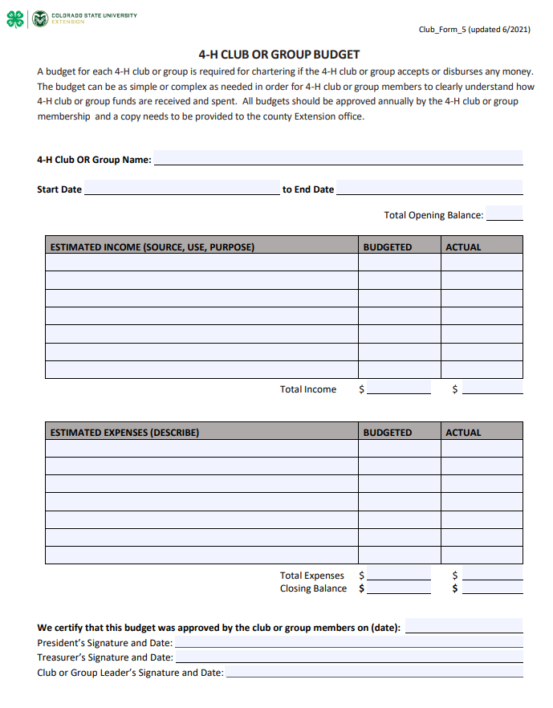
4-H Monthly Treasurer Report
Date:
Group Name:
Beginning Balance |  |  | $
Money received in the month:  From whom and for what purpose | Amount
Total Income
+$
Expenses for the Month-  Paid to whom and for what purpose | Amount
End of Month Balance |  |  | Total Expenses  -$
 |  |  | =$
Add checks you’ve written that haven’t cleared the bank |  |  | +
Subtract deposits not shown on bank statement |  |  | -
Adjusted balance should agree with statement |  |  | =
Attach bank statements, bills, receipt copies to this report
Other notes:
Treasurer’s signature: |  | Date
President’s signature: |  | Date
make copies as needed

Monthly Treasurer Report - Sample
Date: June 2018
Club name: Blue Ribbon All-Stars
Beginning Balance |  |  | $ 143.62
Money received in the month:  From who and for what purpose | Amount
Sold Candy at ball games | 37.50
Dues from Martin Family | 2.50
Interest on bank account | .12
Total Income
+$ 40.12
Expenses for the month-  Paid to who and for what purpose | Amount
Joan Smith – Candy for candy sales | 20.00
Renting room for meeting – Grange | 5.00
Refreshments for meetings, Mrs. Woods | 30.00
Total Expenses
-$ 55.00
End of Month Balance |  |  | = 128.74
Add checks you’ve written that haven’t cleared the bank |  |  | + 0
Subtract deposits not shown on bank statement |  |  | - 0
Adjusted balance should agree with statement |  |  | = 128.74
Attach bank statements, bills, receipt copies to this report
Other notes:
Treasurer’s signature: Kyle Smith |  | Date June 15, 2018
President’s Signature Lindsay Jones |  | Date June 15, 2018

Record of 4-H Club Finances – If no bank account
Cash/Checks Received |  |  | Cash/Money Orders Paid out |  | Start/Balance
Date | From what source | Amount | For what purpose | Amount | $
 |  | $ |  | $ | $
 |  | $ |  | $ | $
 |  | $ |  | $ | $
 |  | $ |  | $ | $
 |  | $ |  | $ | $
 |  | $ |  | $ | $
 |  | $ |  | $ | $
 |  | $ |  | $ | $
 |  | $ |  | $ | $
 |  | $ |  | $ | $
 |  | $ |  | $ | $
 |  | $ |  | $ | $
 |  | $ |  | $ | $
 |  | $ |  | $ | $
 |  | $ |  | $ | $
 |  | $ |  | $ | $
 |  | $ |  | $ | $
 | make copies as needed |  | ending balance |  | $

4-H Event/Activity Income

Club/Group name:
Name of Event |  |  | Date:
Money received for this event  ( From who and how much) | Amount

Total Income
Attach receipt copies to this report.
Other notes:
Treasurer’s signature |  | Date
President’s signature |  | Date
make copies as needed

4-H Event/Activity Expense

Club/Group Name:
Name of Event: |  |  | Date
Expenses for the Event  Paid to who and for what purpose | Amount

Total Expenses
Attach bills and receipt copies to this report
Other notes:
Treasurer signature |  | Date
President’s Signature |  | Date
make copies as needed

Annual 4-H Treasurer Report

Group Name:
County :
For the time period: , 20 to , 20
Balance at beginning of club year: |  |  | $
INCOME - Summarize by source | Amount
Total Income

+$
EXPENSES - Summarize by Category | Amount
Total Expenses
-$
End of Year Balance |  |  | $  =
Add checks you’ve written that haven’t cleared the bank |  |  | $
Subtract deposits not shown on bank statement |  |  | $
Adjusted balance should agree with statement |  |  | $
Attach bank statements, bills, receipt copies to this report
Treasurer’s signature: |  | Date
President’s signature: |  | Date
Club Leader’s signature: |  | Date

Sample - Annual 4-H Treasurer Report

Group Name: Blue Ribbon All-Stars
County : Lake
For the time period: July 1, 2017 to June 30, 2018
Balance at beginning of club year: $146.85 |  |  | $
INCOME - Summarize by source | Amount
Candy sales at ball games | 178.50
Carnival earnings | 254.00
Member dues | 48.00
Interest on bank accounts | 2.54
Total Income

+$483.04
EXPENSES - Summarize by Category | Amount
Supplies for candy sales | 45.00
Supplies for carnival | 65.00
Meeting room rent (12 months @ $5/month)  $5/month) | 60.00
Refreshments for meetings | 75.00
Total Expenses
-$245.00
End of Year Balance |  |  | = $ 384.89  =
Add checks you’ve written that haven’t cleared the bank |  |  | $
Subtract deposits not shown on bank statement |  |  | $
Adjusted balance should agree with statement |  |  | $
Attach bank statements, bills, receipt copies to this report
Treasurer’s signature: Kyle Smith |  | Date: August 20__
President’s signature: Lindsay Jones |  | Date: August 20__
Club Leader’s signature: Karen Woods |  | Date: August 20__

