Activity #3

Moovin’ On: Moving Animals Effectively
Author: Melissa Ring
"Materials reprinted with permission from Ohio State University."

GPP(s): 8
Group Size: 5-25
Length of Activity: 15-20 min

Background:
Livestock handling can be stressful for both the animal and the handler. Understanding the behavior of livestock animals will help handling, reduce stress, and improve both handler and animal safety. Livestock animals can seriously injure handlers and themselves if they become excited or agitated so it is important to understand how to read the animal and its actions to help reduce stress. This activity should help youth understand that anytime you move an animal, changing its daily routine or environment, you place stress on that animal. Much like people, each animal is unique and will handle stress differently.

Objectives:
- Inform youth on the topics of an animals flight zone, instinctual reactions and distractions that impede movements.
- Review information on space requirements and the effects of stress on meat quality

Materials and Supplies:
- Bucking Magnets (or ones similar) 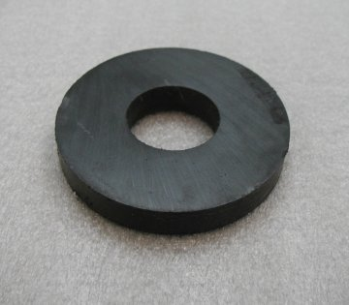 (2 per person)
- Popsicle sticks (many per person)
- (Optional) PowerPoint Projector and laptop)
- Laminated paper cut outs of a cow and a person (small enough to be pasted to the magnets)

Activity Description:

Preparation:
- Go to Temple Grandin’s website to gather information on the three topics to be discussed in this activity, (flight zone, instinctual reactions and distractions that impede movement). You may cover more information if desired.

http://www.grandin.com/behaviour/principles/principles.html
(Be sure to list the distractions that impede movements)

- (Optional) Download power point pictures for identifying distraction pictures
- Glue the laminated cow and human pictures on each magnet (one magnet should be a cow and a different magnet should be a person)
- Gather popsicle sticks. They can be found at any craft store.

Activity One
- Explain the three topics to be covered in this activity. Review the information given on the website.
- Hand out a cow magnet and a person magnet to each member. Give them enough popsicle sticks so they can create their course.
- Explain that the magnets represent the livestock and each member. The goal of this activity is to move the livestock through the popsicle course.
- Have each member create a course. Make sure the magnets are flipped over so that opposite sides face each other (so they do not stick together)
- Each member should move the magnets through the course.

Activity Two
- Explain that improper handling of livestock could cause serious bruising.
- Ask the members to come up with some examples of how a livestock animal could be bruised while moving it.
  - Example would be bad fence corners. Protruding sharp edges could cut an animal as well as cause serious bruising.
  - Protruding bolt or piece of metal will damage hides and bruise the meat.

Activity Three
- Set up laptop and projector
- Go through the PowerPoint while members point out what the distraction in each picture might be.

Discussion

How many youth members have already loaded animals into a trailer or moved them to a new location?

What are some of the difficulties in moving livestock? How can the difficulties be resolved?

What causes stress on the animal and handler?

