*Years in 4-H*

*Club Leader*

***Certificate of Achievement***

*in recognition of successful completion of*

*presented to*

*Colorado 4-H Youth Development Program*

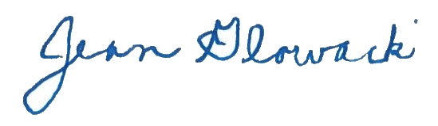

*Colorado 4-H Program Director*

*County Extension Agent*