Colorado 4-H #RaiseYourHand

Photo Contest Winner

Outstanding Colorado 4-H Volunteers

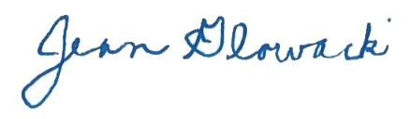
Director, 4-H Program Youth Development

