Entering Group Enrollments
Before You Start
- Gather the program information and the member and volunteer distribution numbers for each of the categories included in the group enrollment.
- The Group Enrollment should only be entered one time for the duration of the program, even if the program is offered over a period of time.

Steps  - Click on Group Enrollments in the navigation pane.  - Click the blue Add Group Enrollment button. | Screenshots  (Screen appearance may vary per state)  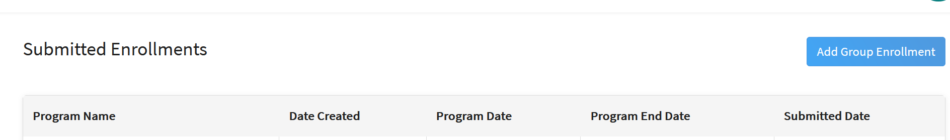
- Complete each of the Program fields with the information specific to the group enrollment. Some fields are required.  - Program Name  - Description  - Start Date  - End Date  - 4-H Year  - Delivery Mode  - Presenter  - Location  - Number of Hours  - Number of Youth from military families | 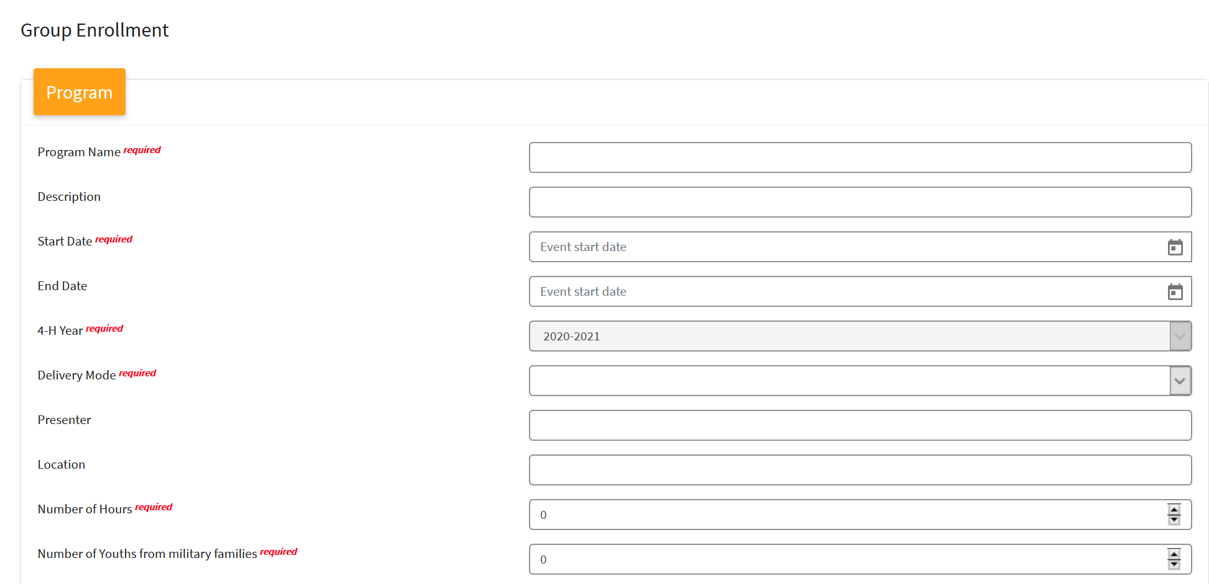
- Select the Project area from the drop-down menu and click Add Project. Repeat for each project in the program.
- Complete the Gender Distribution fields. This includes the county of total males and females, and the number of duplicated members (enrolled members) for both males and females. | 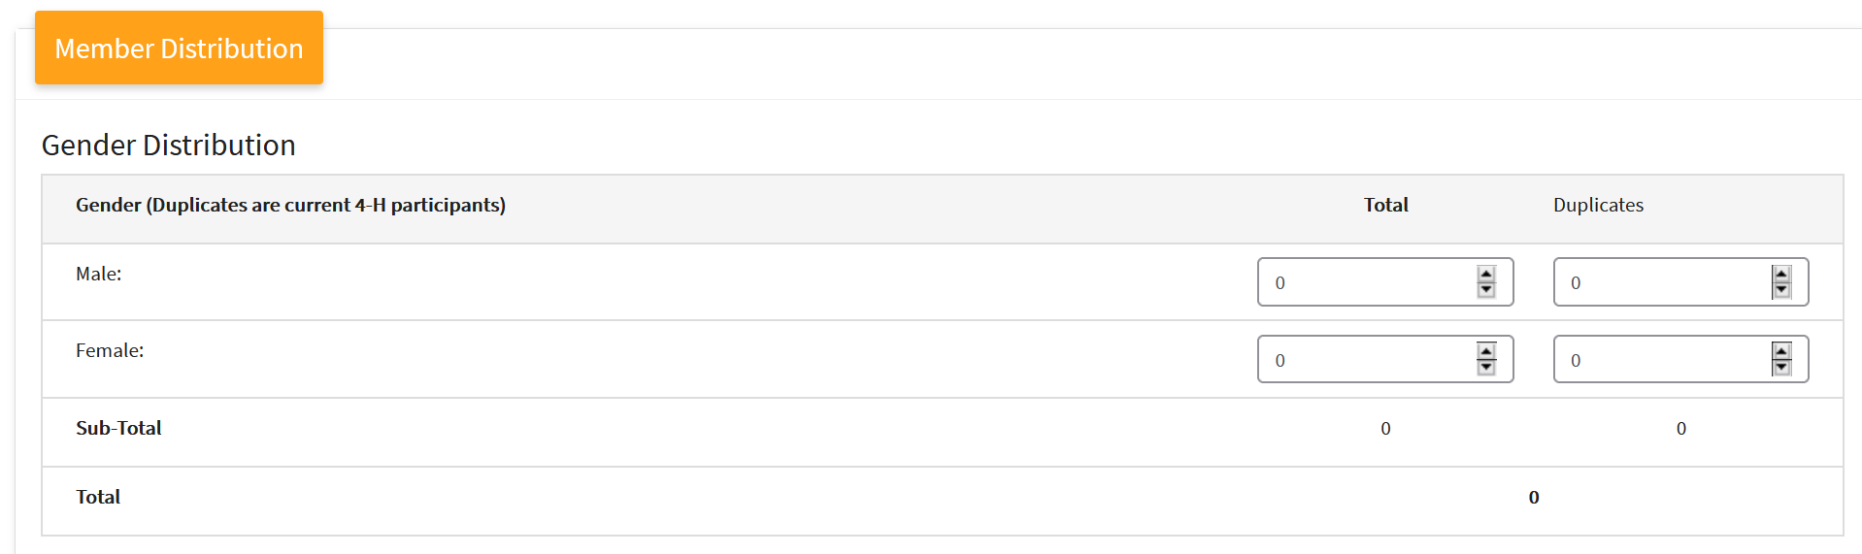
- Complete the Racial Distribution fields for the non-duplicates. This includes the count of each racial group according to their ethnicity (Hispanic or Non-Hispanic). This total must match the total of non-duplicated participants from the first section.  - White only  - Black or African American Only  - American Indian or Alaska Native Only  - Asian Only  - Native Hawaiian/Pacific Islander Only  - Balance (other combinations) | 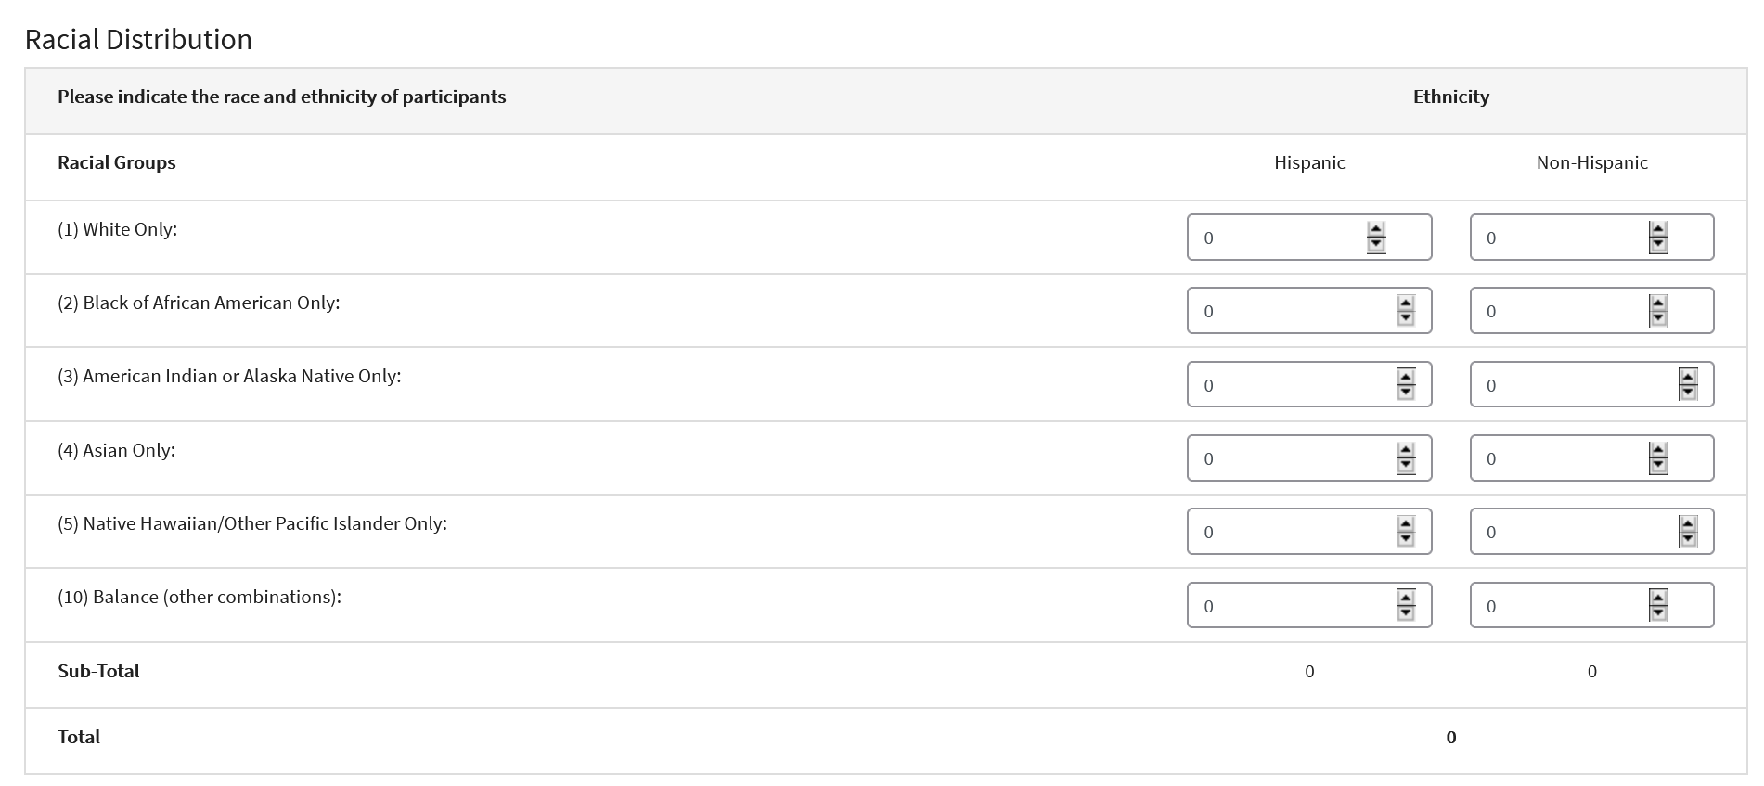
- Complete the Residence Distribution for the non-duplicate participants. This includes:  - Farm  - Rural (under 10,000)  - Town (10,000 – 50,000)  - Suburb of Cities (less than 50,000)  - Central Cities (Greater than 50,000) | 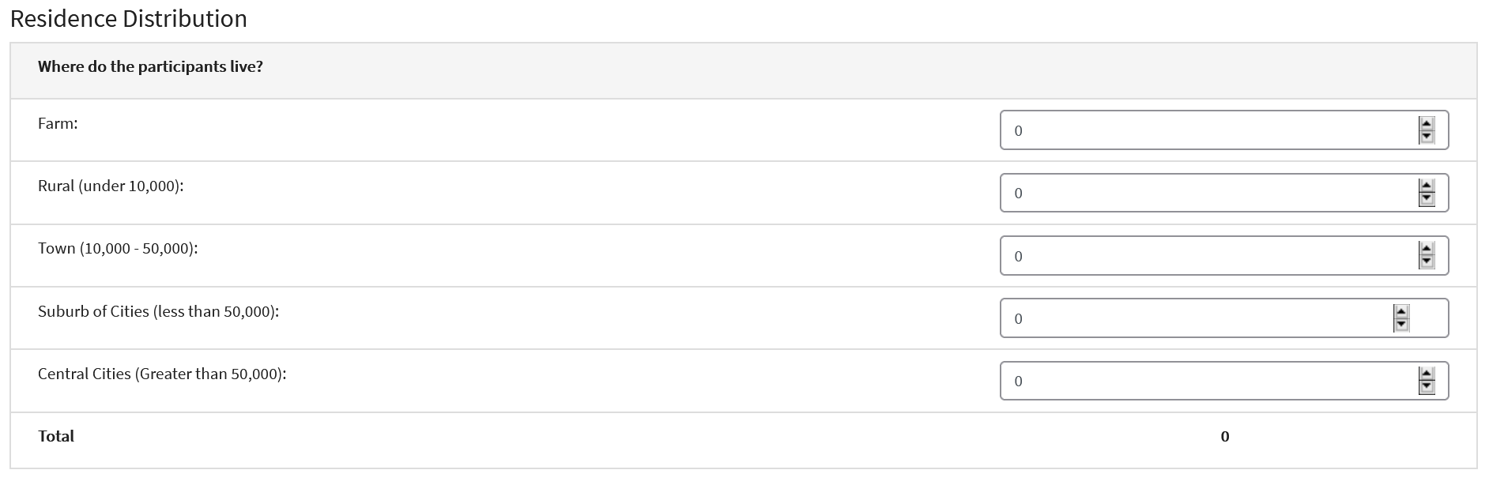
- Complete the Grade Distribution fields for the non-duplicate participants. | 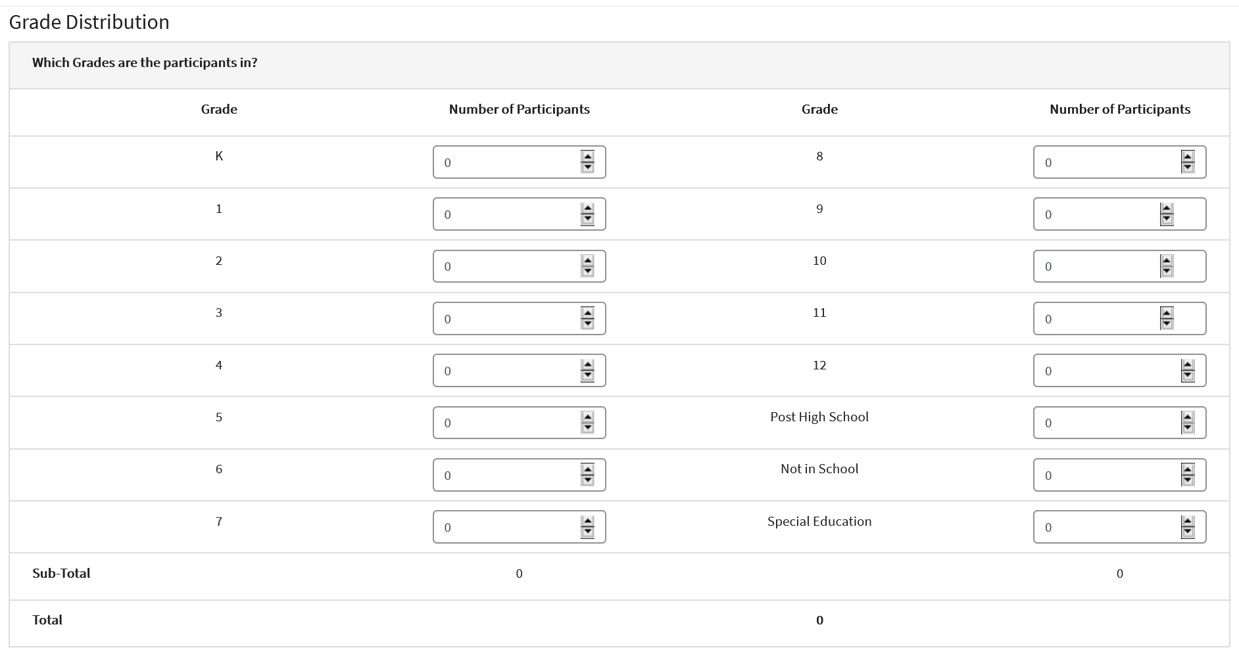
- Complete the Racial Distribution of Volunteers. | 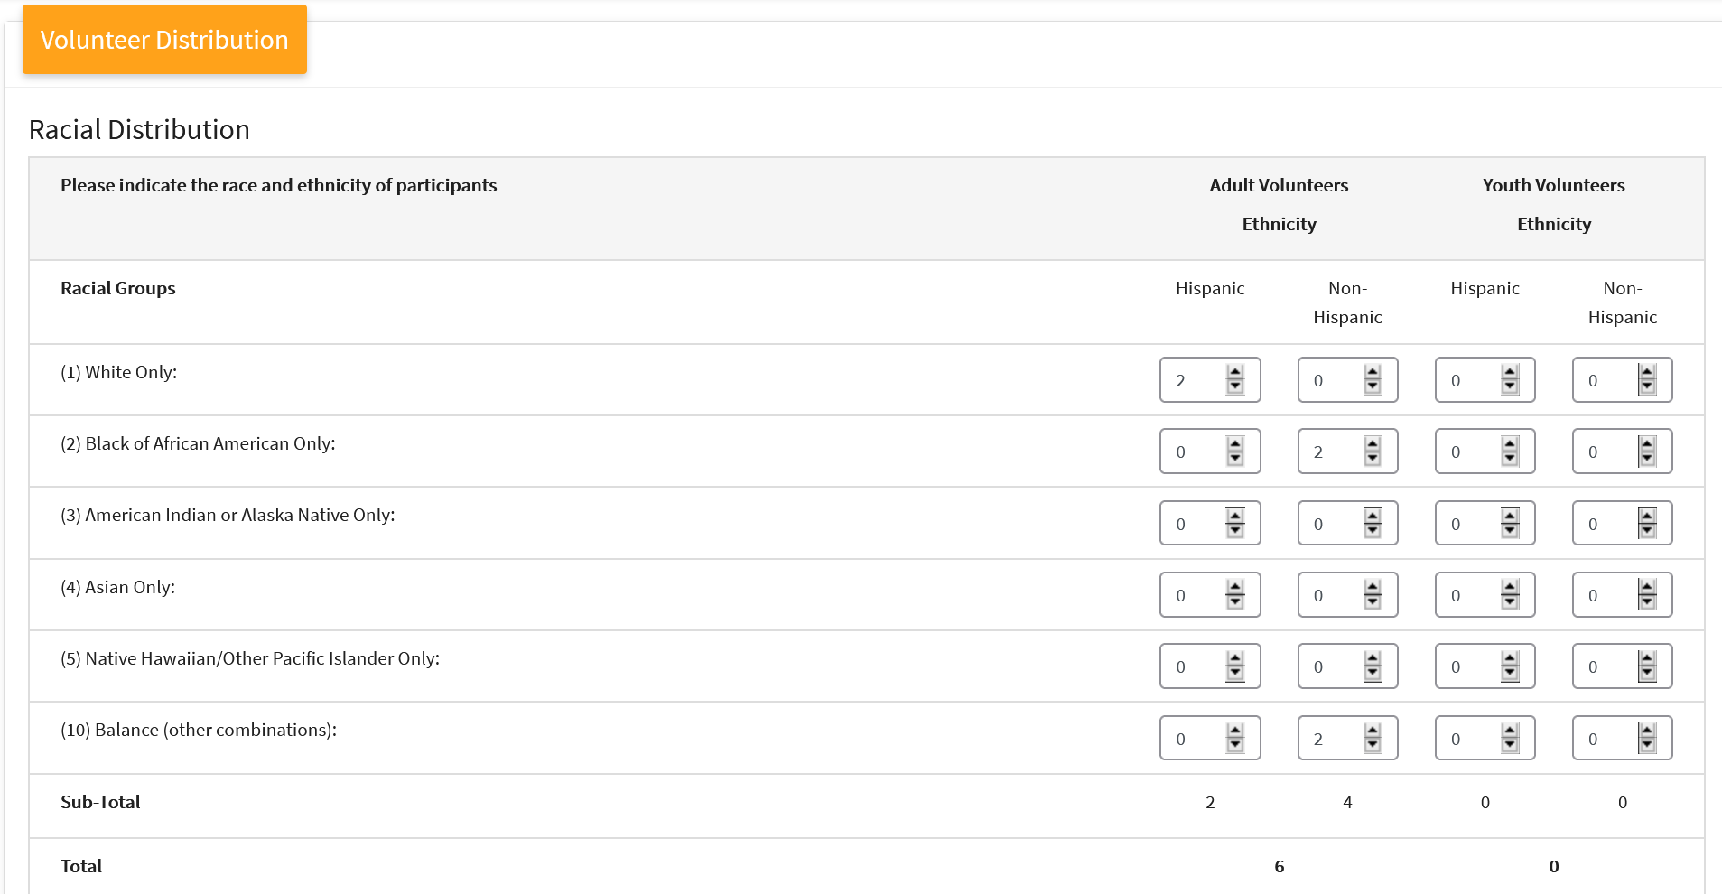
- Complete the Adult Classification Distribution fields. This is the distribution of adult volunteers for this program.  - Direct (as defined by your institution)  - Indirect (as defined by your institution) | 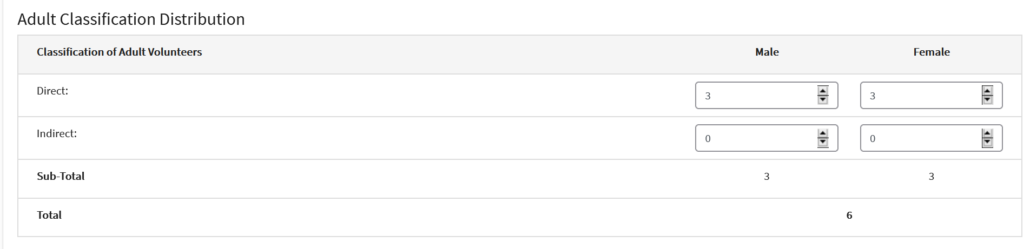
- Complete the Youth Classification Distribution fields. This is the distribution of youth volunteers for this program.  - Direct (as defined by your institution)  - Indirect (as defined by your institution) | 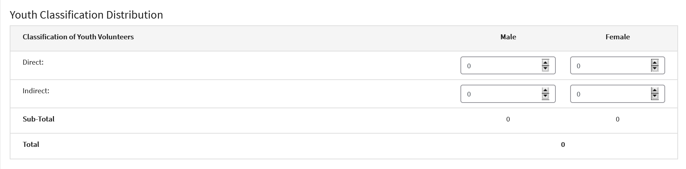
- Complete the Training Distribution fields. These are the new Volunteers Trained Through 4-H.  - Leadership (as defined by your institution)  - Parenting (as defined by your institution)  - Other (as defined by your institution) | 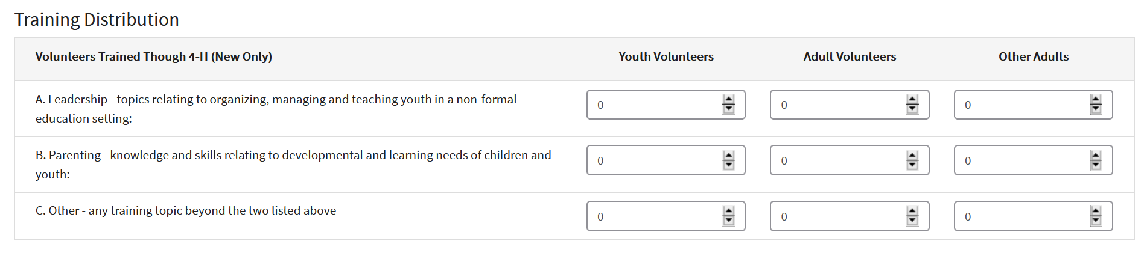
- Check the box to submit the form.  - Click Save. | 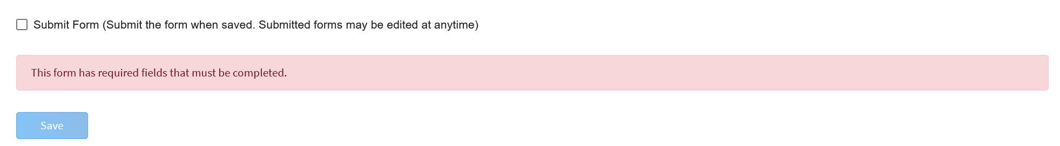
Tips
- The member distribution totals must match for each category. Duplicates (current 4-H members) are removed from the Male and Female totals.

